DECENTRALIZED AUTONOMOUS ORGANIZATION (DAO) WITH ON-CHAIN GOVERNANCE

PROJECT REPORT

Submitted by
KISHORE S (7376221CS205)
KARTHICK D (7376221CS187)
PRANESH S (7376221SE136)

In partial fulfilment for the award of the degree
of
BACHELOR OF ENGINEERING
in

COMPUTER SCIENCE AND ENGINEERING



BANNARI AMMAN INSTITUTE OF TECHNOLOGY
(An Autonomous Institution Affiliated to Anna University, Chennai) SATHYAMANGALAM-638401

ANNA UNIVERSITY: CHENNAI 600 025

APRIL 2026
BONAFIDE CERTIFICATE

Certified that this project report “DECENTRALIZED AUTONOMOUS ORGANIZATION (DAO) WITH ON-CHAIN GOVERNANCE” is the bonafide work of “KISHORE S (7376221CS205), KARTHICK D (7376221CS187), PRANESH S (7376221SE136)” who carried out the project work under my supervision.

Dr. SASIKALA D Ms. KAYALVIZHI B
HEAD OF THE DEPARTMENT ASSISTANT PROFESSOR
Department of Computer Science Department of Computer Science
and Engineering and Engineering
Bannari Amman Institute of Technology Bannari Amman Institute of Technology

Submitted for Project Viva Voce examination held on ..........................................

Internal Examiner I Internal Examiner II
DECLARATION

We affirm that the project work titled “DECENTRALIZED AUTONOMOUS ORGANIZATION (DAO) WITH ON-CHAIN GOVERNANCE” being submitted in partial fulfillment for the award of the degree of Bachelor of Engineering in Computer Science and Engineering is the record of original work done by us under the guidance of Ms. KAYALVIZHI B Assistant Professor, Department of Computer Science and Engineering. It has not formed a part of any other project work(s) submitted for the award of any degree or diploma, either in this or any other University.

KISHORE S KARTHICK D
(7376221CS205) (7376221CS187)

PRANESH S
(7376221SE136)

I certify that the declaration made above by the candidates is true.

Ms. KAYALVIZHI B
(ASSISTANT PROFESSOR)
ACKNOWLEDGEMENT

We would like to enunciate heartfelt thanks to our esteemed Chairman Dr S.V. Balasubramaniam and the respected Principal Dr C. Palanisamy for providing excellent facilities and support during the course of studying this institute.

We are grateful to Dr. Sasikala D, Head of the Department, Department of Computer Science and Engineering for her valuable suggestions to carry out the project work successfully.

We wish to express our sincere thanks to Faculty guide Ms. Kayalvizhi B, Assistant Professor, Department of Computer Science and Engineering, for her constructive ideas, inspirations, encouragement, excellent guidance, and much-needed technical support extended to complete our project work.

We would like to thank our friends, faculty and non-teaching staff who have directly and indirectly contributed to the success of this project.

KISHORE S (7376221CS205)

KARTHICK D (7376221CS187)

PRANESH S (7376221SE136)

INTERNSHIP REPORT

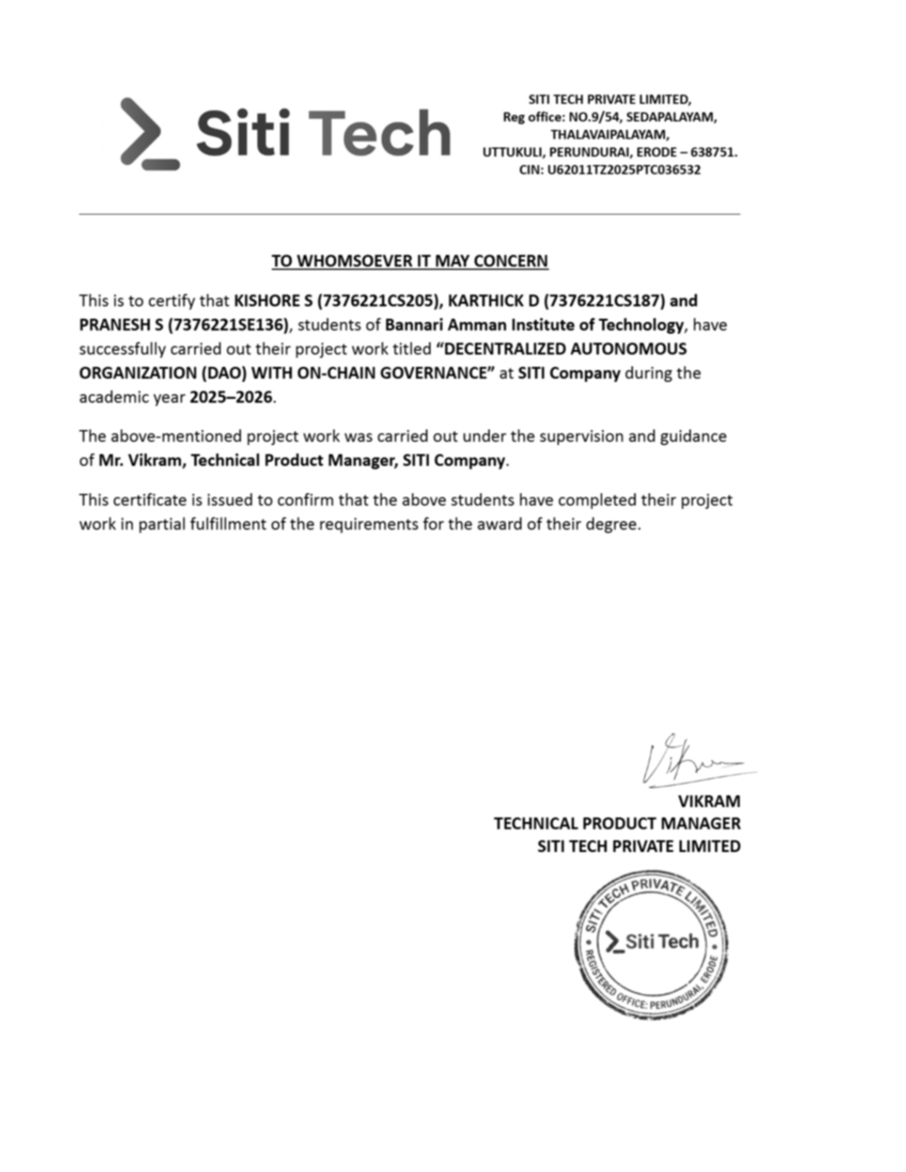ABSTRACT

The Decentralized Autonomous Organization (DAO) with On-Chain Governance is a blockchain-based system designed to enable transparent, secure, and decentralized decision-making without reliance on centralized authorities. Traditional governance systems often suffer from issues such as lack of transparency, delayed decision processes, and limited stakeholder participation. To overcome these challenges, this project leverages smart contracts and blockchain technology to create an automated and trustless governance framework. The system is built using Ethereum-based smart contracts, along with modern web technologies for frontend interaction, ensuring a seamless and user-friendly decentralized application (DApp). The DAO allows participants holding governance tokens to create proposals, participate in voting, and influence decision-making processes in a transparent manner. Each proposal undergoes a structured lifecycle including creation, voting, quorum validation, and execution, all of which are recorded immutably on the blockchain.
The platform integrates a governance dashboard that provides real-time insights into proposal status, voting activity, and participation metrics. Token-based voting ensures fairness and proportional representation, while automated execution of approved proposals eliminates the need for manual intervention. Security mechanisms such as access control, validation checks, and protection against common smart contract vulnerabilities are incorporated to ensure system reliability. The DAO framework enhances transparency, accountability, and efficiency by making all governance actions publicly verifiable.

Keywords: Decentralized Autonomous Organization (DAO), On-Chain Governance, Smart Contracts, Blockchain, Ethereum, Token-Based Voting, Decentralized Applications (DApps), Governance Tokens, Transparency, Web3.

TABLE OF CONTENTS

CHAPTER NO | TITLE | PAGE NO
 | ACKNOWLEDGEMENT | 4
 | INTERNSHIP REPORT | 5
 | ABSTRACT | 6
 | TABLE OF CONTENTS | 7
 | LIST OF FIGURES | 13
1 | INTRODUCTION | 14
1.1 | BACKGROUND OF THE WORK | 15
1.2 | MOTIVATION | 15
1.3 | PROPOSED SOLUTION | 16
1.4 | OBJECTIVE | 17
1.5 | OUTCOME | 18
2 | LITERATURE SURVEY | 19
3 | OBJECTIVE AND METHODOLOGY | 22
3.1 | OBJECTIVES | 22
 | 3.1.1 REAL-TIME ON-CHAIN GOVERNANCE AND MONITORING | 22
 | 3.1.2 AUTOMATED PROPOSAL EXECUTION AND NOTIFICATION SYSTEM | 23
 | 3.1.3 TOKEN-BASED ACCESS CONTROL FOR GOVERNANCE SECURITY | 24
 | 3.1.4 ANALYTICS AND REPORTING FOR DATA-DRIVEN DECISION MAKING | 26
3.2 | FLOW DIAGRAM OF THE PROPOSED WORK | 28
 | 3.2.1 CORE SYSTEM ARCHITECTURE | 30
 | 3.2.2 DAO GOVERNANCE AND WORKFLOW METHODOLOGY | 32
 | 3.2.3 INTEGRATION WITH WEB3 INTERFACE AND DECENTRALIZED SYSTEMS | 33
3.3 | PROPOSED METHODOLOGY | 34
 | 3.3.1 GOVERNANCE DATA COLLECTION AND MANAGEMENT | 35
 | 3.3.2 CORE FUNCTIONAL MODULES | 36
 | 3.3.3 SYSTEM DEVELOPMENT | 38
 | 3.3.4 FEATURE INTEGRATION AND AUTOMATION | 40
 | 3.3.5 REAL-TIME WORK – FLOW AUTOMATION | 41
 | 3.3.6 SECURITY AND SCALABILITY | 42
3.4 | PERFORMANCE ENHANCEMENT | 43
 | 3.4.1 DATABASE OPTIMIZATION | 43
 | 3.4.2 LOAD BALANCING | 43
 | 3.4.3 ASYNCHRONOUS PROCESSING | 44
4 | PROPOSED WORK MODULE | 45
4.1 | PROPOSED WORK | 45
4.2 | METHODOLOGY OF THE PROPOSED WORK | 47
 | 4.2.1 USER AUTHENTICATION MODULE | 47
 | 4.2.2 GOVERNANCE TOKEN MANAGEMENT MODULE | 47
 | 4.2.3 PROPOSAL CREATION MODULE | 48
 | 4.2.4 VOTING MECHANISM MODULE | 48
 | 4.2.5 PROPOSAL EXECUTION MODULE | 48
 | 4.2.6 TREASURY MANAGEMENT MODULE | 49
 | 4.2.7 ON-CHAIN DATA AND RECORD MANAGEMENT MODULE | 49
5 | RESULT AND DISCUSSION | 50
5.1 | RESULTS | 50
 | 5.1.1 WALLET AUTHENTICATION AND USER MANAGEMENT | 51
 | 5.1.2 PROPOSAL CREATION AND MANAGEMENT | 52
 | 5.1.3 VOTING MECHANISM AND GOVERNANCE PARTICIPATION | 53
 | 5.1.4SMART CONTRACT EXECUTION AND AUTOMATION | 54
 | 5.1.5 GOVERNANCE DASHBOARD AND USER INTERFACE PERFORMANCE | 55
5.2 | DISCUSSION | 57
 | 5.2.1 PRACTICAL INTERPRETATION OF RESULTS | 58
 | 5.2.2 COMPARISON WITH TRADITIONAL SYSTEMS | 58
5.3 | SIGNIFICANCE, STRENGTHS AND LIMITATIONS | 59
 | 5.3.1 SIGNIFICANCE OF THE DAO SYSTEM | 59
 | 5.3.2 STRENGTH OF THE SYSTEM | 59
 | 5.3.3 LIMITATIONS | 60
5.4 | COST BENEFIT ANALYSIS | 60
6 | CONCLUSION AND SUGGESTIONS FOR THE FUTURE WORK | 62
6.1 | CONCLUSION | 62
6.2 | SUGGESTIONS FOR FUTURE WORK | 63
 | 6.2.1 INTEGRATION WITH LAYER-2 SCALING SOLUTIONS | 63
 | 6.2.2 AI-BASED GOVERNANCE ANALYTICS ENGINE | 63
 | 6.2.3 MOBILE AND DECENTRALIZED APPLICATION DEVELOPMENT | 64
 | 6.2.4 CROSS-CHAIN DEPLOYMENT | 64
 | 6.2.5 ADVANCED GOVERNANCE MECHANISMS | 64
 | 6.2.6 ENHANCED SECURITY AND SMART CONTRACT AUDITING | 64
 | 6.2.7 ADVANCED ANALYTICS AND VISUALIZATION DASHBOARDS | 65
 | 6.2.8 INTEGRATION WITH REAL WORLD APPLICATIONS | 65
 | 6.2.9 DECENTRALIZED IDENTITY INTEGRATION | 65
7 | REFERENCES | 66
 | APPENDICES | 78
 | BILL OF MATERIALS | 68
 | WORK CONTRIBUTION | 74
 | PLAGARISM REPORT | 77

LIST OF FIGURES

FIGURE NO | FIGURE NAME | PAGE NO
3.1  3.2 | WORKFLOW DIAGRAM  FACULTY WORKLOG WORKFLOW DIAGRAM | 29  30
5.1 | HOME PAGE | 50
5.2 | DAO GOVERNANCE DASHBOARD INTERFACE | 51
5.3 | PROPOSAL/ACTIVITY MANAGEMENT INTERFACE | 52
5.4 | DAO MEMBER TRACKER | 53
5.5 | DAO MANAGEMENT INTERFACE | 54
5.6 | DAO ROLES AND PERMISSION MANAGEMENT INTERFACE | 55
5.7 | ADD A NEW PROJECT MODULE INTERFACE | 56
5.8 | ROLE ANNOUNCEMENT INTERFACE | 56

CHAPTER 1 INTRODUCTION
In the modern digital era, managing organizational governance in a transparent, secure, and decentralized manner has become a significant challenge. Traditional organizational systems rely on centralized authorities to make decisions, manage funds, and control operations. This often leads to issues such as lack of transparency, delayed decision-making, limited stakeholder participation, and potential misuse of power. As organizations grow in size and complexity, ensuring trust, accountability, and efficient governance becomes increasingly difficult.
The Decentralized Autonomous Organization (DAO) With On-Chain Governance is developed to address these challenges by leveraging blockchain technology and smart contracts. This system provides a decentralized platform where governance decisions are made collectively by stakeholders through transparent and automated processes. The DAO enables users to create proposals, participate in voting, and execute decisions without the need for intermediaries.
This web-based decentralized application is built using blockchain technologies such as Ethereum, along with Web3 frameworks and smart contracts written in Solidity. The system ensures immutability, transparency, and trust by recording all governance activities on-chain. It enhances participation, reduces manual intervention, and provides a secure and efficient governance model.
Overall, this project aims to transform traditional governance mechanisms into a decentralized, automated, and transparent system, making it suitable for modern digital communities, organizations, and decentralized ecosystems. Additionally, the system supports real-time governance updates, secure voting mechanisms, and scalable architecture, making it a future-ready solution for decentralized decision-making environments.

1.1 BACKGROUND OF THE WORK
In traditional organizational structures, governance and decision-making are typically controlled by a centralized authority such as management boards or administrative bodies. These systems often suffer from inefficiencies, lack of transparency, and limited participation from stakeholders. Decision-making processes can be slow, biased, and prone to manipulation due to human intervention and lack of accountability.
With the advancement of blockchain technology, a new paradigm known as Decentralized Autonomous Organizations (DAOs) has emerged. DAOs operate on smart contracts that automatically enforce rules and execute decisions based on predefined conditions. This eliminates the need for intermediaries and ensures that all actions are transparent and tamper-proof.
However, implementing an efficient and secure DAO system requires careful design of governance mechanisms, voting strategies, and smart contract architecture. The DAO with On-chain Governance project is developed to provide a structured and practical solution for decentralized governance. It enables stakeholders to actively participate in decision-making while ensuring fairness, transparency, and security. By utilizing blockchain technology, this system ensures that all governance actions are recorded permanently, providing an immutable audit trail. This enhances trust among participants and supports efficient management of decentralized organizations.
1.2 MOTIVATION
The motivation behind developing the Decentralized Autonomous Organization (DAO) With On-Chain Governance arises from the limitations of traditional centralized governance systems. These systems often lack transparency, involve delays in execution, and restrict stakeholder participation, which can lead to inefficiencies and trust issues. In centralized systems, decisions are made by a limited group of individuals, which may not always reflect the interests of all stakeholders. Additionally, manual processes and lack of automation increase the chances of errors and inconsistencies. To overcome these challenges, this project proposes a decentralized governance system that enables transparent, automated, and community-driven decision-making. By using blockchain and smart contracts, the system ensures that governance rules are enforced without bias and that all participants have equal opportunities to contribute.
This project also aims to explore the potential of Web3 technologies in transforming organizational management. It focuses on building a scalable and secure platform that supports real-time participation, transparent voting, and automated execution of decisions.
Challenges Faced
- Centralized Decision-Making: Traditional systems rely on a single authority, leading to reduced transparency and trust issues.
- Lack of Transparency: Governance processes are often not visible to all stakeholders.
- Limited Participation: Stakeholders have restricted involvement in decision-making processes.
- Manual and Delayed Processes: Decision execution and record maintenance are time-consuming and inefficient.
These challenges highlight the need for a decentralized and automated governance model. The DAO system addresses these issues by providing a transparent, secure, and efficient platform for managing organizational decisions.
1.3 PROPOSED SOLUTION
To overcome the limitations of traditional governance systems, the proposed solution introduces a decentralized, blockchain-based governance platform that ensures transparency, automation, and secure participation.
- Decentralized Governance Platform
Develop a blockchain-based DAO system where governance decisions are managed through smart contracts, enabling trustless and transparent operations.
- On-Chain Voting Mechanism
Implement token-based voting where stakeholders can participate in decision-making processes, ensuring fair representation and proportional influence.
- Automated Proposal Execution
Enable automatic execution of approved proposals through smart contracts, eliminating manual intervention and ensuring reliability.
Benefits
- Enhanced Transparency: All governance activities are recorded on the blockchain, ensuring visibility and accountability.
- Decentralized Decision-Making: Eliminates reliance on central authorities and promotes community-driven governance.
- Improved Security: Smart contracts ensure secure and tamper-proof execution of decisions.
- Scalable and Efficient System: The architecture supports scalability and integration of future enhancements.
1.4 OBJECTIVE
The primary objective of this project is to design and develop a Decentralized Autonomous Organization (DAO) With On-Chain Governance that enables transparent, secure, and automated decision-making using blockchain technology. The system aims to replace traditional centralized governance mechanisms with a decentralized approach where stakeholders actively participate in proposal creation, voting, and execution. It focuses on ensuring fairness, transparency, and efficiency in organizational management. The project also aims to implement smart contracts for governance logic, develop token-based voting mechanisms, and create an interactive user interface for seamless user interaction. By integrating blockchain technology with modern web frameworks, the system ensures secure and real-time governance operations.
Additionally, the system supports scalability, allowing future integration of advanced features such as governance analytics, delegation mechanisms, and cross-chain compatibility. Overall, the project aims to build a robust and future-ready decentralized governance platform that enhances participation, trust, and operational efficiency.
1.5 OUTCOME
The implementation of the Decentralized Autonomous Organization (DAO) With On-Chain Governance resulted in a fully functional decentralized platform that successfully demonstrates automated and transparent governance.The system enables users to create proposals, participate in voting, and execute decisions through smart contracts without relying on centralized authorities. All governance activities are recorded on the blockchain, ensuring immutability and transparency.
The platform provides a secure and efficient mechanism for managing organizational decisions, reducing manual effort and eliminating the risk of manipulation. Token-based voting ensures fair participation, while automated execution enhances reliability and speed. Additionally, the system demonstrates scalability and adaptability, allowing future enhancements such as advanced analytics, governance optimization, and integration with other decentralized applications.
In conclusion, the project successfully showcases how blockchain technology can transform traditional governance systems into decentralized, transparent, and efficient models. It highlights the potential of DAOs in redefining organizational structures and enabling trustless collaboration in digital ecosystems.

CHAPTER 2

LITERATURE SURVEY
The Concept of Decentralized Autonomous Organizations (DAOs) Has Emerged as A Transformative Approach to Organizational Governance by Leveraging Blockchain Technology and Smart Contracts. This Section Reviews Existing Research Works Related to Decentralized Governance, Blockchain-based Systems, Smart Contracts, And Distributed Decision-making Mechanisms.
Das And Roy (2024) Presented A Cloud-integrated System for Real-time Data Synchronization Using Firebase. While Their Approach Improved Accessibility and Collaboration, It Relied on Centralized Cloud Infrastructure, Leading to Concerns Regarding Data Ownership and Privacy. In Contrast, DAO-based Systems Utilize Blockchain Technology to Ensure Decentralization, Where Data Is Stored Across Distributed Nodes, Eliminating the Need for Centralized Control and Enhancing Trust Through Immutability.
Bajwa Et Al. (2024) Proposed A Resource Optimization Framework That Focuses on Efficient Task Distribution and Workload Balancing. Their Study Highlights the Importance of Fair Allocation Mechanisms in Complex Systems. Similarly, DAO Governance Models Implement Token-based Voting and Delegation Mechanisms to Ensure Equitable Participation and Balanced Decision-making Among Stakeholders Without Human Bias.
Rao And Iyer (2023) Developed A Web-based Management System Using Traditional Technologies Such as PHP And MySQL. Although Functional, The System Lacked Scalability, Transparency, And Real-time Interaction Capabilities. Blockchain-based DAO Systems Overcome These Limitations by Providing Transparent, Tamper-proof, And Scalable Solutions Where All Transactions and Governance Activities Are Permanently Recorded On-chain.
Alvarez Et Al. (2023) Designed an Automated Scheduling System Using Django and PostgreSQL to Optimize Resource Allocation. However, Their System Encountered Performance Issues During High Concurrent Usage. DAO Systems Address Such Limitations Through Distributed Consensus Mechanisms, Which Enable Parallel Processing Across Nodes, Ensuring System Reliability and Scalability Without Bottlenecks.
Verma Et Al. (2023) Introduced A Performance Monitoring System with Dashboard Analytics That Enhanced Decision-making Through Data Visualization. In DAO Systems, Similar Analytical Capabilities Can Be Integrated Using Blockchain Data to Visualize Voting Trends, Proposal Outcomes, And Governance Participation, Supporting Data-driven Decision-making In Decentralized Environments.
Kumar And Thomas (2022) Proposed A Role-based Access Control Mechanism to Ensure Secure Data Management in Digital Systems. While Effective in Centralized Systems, DAO Governance Extends This Concept by Introducing Token-based Or Permissionless Access Control, Where Participation Rights Are Determined by Smart Contracts and Token Ownership, Eliminating the Need for Centralized Authentication.
Patel Et Al. (2022) Developed A Workload Optimization Model Using Statistical Techniques to Improve Task Allocation Efficiency. This Concept Is Reflected in DAO Governance Through Mechanisms Such as Proposal Voting, Incentive Structures, And Delegation Models That Ensure Efficient and Fair Decision-making Without Manual Intervention.
Chowdhury Et Al. (2022) Emphasized Automation in Academic Management Systems but Highlighted Limitations in Integrating Multiple Functional Modules. DAO Systems Provide a Unified Governance Framework Where Decision-making, Financial Management, And Operational Rules Are Integrated into A Single Blockchain-based Architecture, Ensuring Seamless Automation and Transparency.
Nair And Mehta (2022) Developed A Performance Tracking Application with Visualization Features but Lacked Integration with Core Functional Systems. DAO Platforms Overcome This Limitation by Combining Governance Logic, Financial Transactions, And Data Transparency Into a Single Decentralized System, Ensuring Consistency and Reliability.
Sharma And Gupta (2021) Highlighted the Importance of RESTful APIs In Enabling Communication Between System Components. While APIs Are Essential in Traditional Systems, DAO Applications Utilize Web3 Interfaces and Smart Contract Interactions, Allowing Direct Communication with Blockchain Networks and Reducing Dependency on Intermediaries.
Singh Et Al. (2021) Explored Cloud-based Tracking Systems That Improved Data Accessibility but Relied on Third-party Infrastructure. DAO Systems Provide a Decentralized Alternative Where Data Is Distributed Across Multiple Nodes, Ensuring High Availability, Fault Tolerance, And Elimination of Single Points of Failure.
Buterin (2014), The Creator of Ethereum, Introduced the Concept of Smart Contracts and Decentralized Applications, Which Form the Foundation of DAO Systems. Ethereum Enables Programmable Blockchain Functionality, Allowing Developers to Build Autonomous Systems Where Governance Rules Are Enforced Through Code.
Hassan And De Filippi (2021) Explored the Legal and Technical Aspects of DAOs, Highlighting Their Potential to Replace Traditional Organizational Structures with Algorithmic Governance. Their Work Emphasizes the Importance of Transparency, Accountability, And Decentralization in Modern Digital Organizations.
Wright And De Filippi (2015) Discussed the Concept of Decentralized Blockchain Governance and Its Impact on Organizational Models.Their Study Demonstrates How Blockchain Technology Can Eliminate Intermediaries and Enable Trustless Collaboration AmongParticipants.

CHAPTER 3
OBJECTIVE AND METHODOLOGY
3.1 OBJECTIVES
3.1.1 Real-Time On-Chain Governance Monitoring

In Traditional Organizational Systems, Governance Activities Are Often Opaque, Delayed, And Controlled by Central Authorities, Leading to Lack of Transparency and Inefficient Decision Tracking. A Primary Objective of This Project Is to Enable Real-time on-chain Governance Monitoring, Where Every Action Performed Within the DAO Is Instantly Recorded and Reflected on the Blockchain.

Dynamic Governance Tracking: All Governance Activities Such as Proposal Creation, Voting Participation, Vote Counting, And Execution Status Are Continuously Updated On-chain. Smart Contracts Emit Events for Every Action, Which Are Captured by The Frontend to Provide Real-time Updates. This Ensures That Users Always Interact with The Most Recent and Accurate State of the System.

Decentralized Transparency Dashboard: A Web3-enabled Dashboard Fetches Data Directly from The Blockchain Using Libraries Such as Ethers.js. It Displays Active Proposals, Voting Statistics, Quorum Status, And Execution Results Without Relying on Centralized Servers. The Dashboard Acts as A Real-time Interface for Monitoring DAO Activities with Complete Transparency.

Efficient Decision Monitoring: Users Can Track Proposal Lifecycle Stages Including Creation, Activation, Voting, And Execution in Real Time. This Continuous Monitoring Improves Participation and Enables Users to Make Timely Decisions Based on Live Governance Data.

Event-Driven Architecture: Blockchain Event Logs Are Used to Trigger UI Updates and Notifications, Ensuring Efficient Synchronization Between On-chain Data and User Interfaces Without Polling Overhead.

Contribution

This Objective Establishes a Transparent and Trustless Monitoring System Where All Governance Activities Are Publicly Verifiable. It Eliminates Information Delays, Enhances User Engagement, And Provides a Reliable Mechanism for Tracking Organizational Decisions.

3.1.2 Automated Proposal Execution and Notification System

In Conventional Systems, Decision Implementation Requires Manual Approval and Execution, Which Can Introduce Delays, Errors, And Bias. This Project Aims to Fully Automate Proposal Execution Using Smart Contracts While Enhancing Communication Through Event-driven Notifications.
- Automated Proposal Execution: Smart Contracts Are Programmed with Predefined Conditions Such as Voting Deadline, Quorum Threshold, And Majority Percentage. Once These Conditions Are Satisfied, The Contract Automatically Executes the Associated Action Without External Intervention.This Automation Ensures Deterministic and Tamper-proof Decision Implementation.
- Event-Based Notification System: Blockchain Events Such as Proposal Creation, Vote Casting, And Execution Are Captured by The Frontend to Notify Users in Real Time. Integration With Notification Services Can Further Enhance User Awareness.
- Voting Alerts and Deadlines: Time-based Triggers Are Used to Inform Users About Ongoing Voting Periods, Expiry Deadlines, And Execution Status. This Improves Participation Rates and Reduces Missed Voting Opportunities.
- Gas Optimization During Execution: Efficient Smart Contract Design Minimizes Gas Costs During Proposal Execution by Avoiding Redundant Computations and Using Optimized Data Structures.
Contribution
This Objective Eliminates Human Dependency in Governance Execution, Reduces Delays, And Ensures Accurate and Consistent Implementation of Decisions. It Also Improves User Engagement Through Real-time Notifications and Alerts.

3.1.3 Token-Based Access Control and Governance Security
In a Decentralized Autonomous Organization (DAO), traditional role-based access control (RBAC) is replaced with token-based governance mechanisms, ensuring that authority is distributed among participants rather than controlled by a central administrator. Secure access control is essential to maintain fairness, prevent malicious activities, and ensure that only eligible participants can perform governance actions.
- Role Definition through Token Ownership: Instead of fixed roles like Admin and Faculty, the system defines user privileges based on governance token holdings.
- Token Holders: Users who possess governance tokens can participate in voting and decision-making processes.
- Proposers: Users holding a minimum threshold of tokens are eligible to create proposals.
- Core Contributors (Optional Advanced Role): Users with higher token stakes or delegated authority may have enhanced privileges such as proposal execution or treasury access. This dynamic role structure ensures decentralized participation and eliminates hierarchical control.
- Permission Control via Smart Contracts: All permissions are enforced through immutable smart contracts deployed on the blockchain.
- Only eligible users can create proposals based on token thresholds.
- Voting rights are proportional to token holdings.
- Sensitive operations such as treasury fund transfers or proposal execution are triggered only when predefined conditions (quorum and majority) are met. This removes manual intervention and ensures trustless and automated governance.
- On-Chain Activity Logging: Every governance action such as proposal creation, vote casting, and execution is permanently recorded on the blockchain.
- These records are immutable and publicly verifiable.
- Transaction hashes provide proof of actions taken by users.
- This ensures complete transparency and traceability of all DAO activities.
- Security Mechanisms in Smart Contracts: The system incorporates multiple security measures to protect against vulnerabilities:
- Re-entrancy Protection to prevent recursive attacks
- Access Modifiers to restrict unauthorized function calls
- Input Validation to avoid invalid transactions
- Time Locks for delayed execution of critical proposals
These mechanisms ensure robustness and safeguard DAO operations.
- Decentralized Identity and Anti-Sybil Measures: To prevent fake or duplicate identities (Sybil attacks), the system can integrate decentralized identity solutions or token staking requirements. This ensures that governance participation reflects genuine stakeholders.
Contribution
This approach transforms traditional access control into a decentralized, transparent, and trustless governance model. By leveraging blockchain technology and token-based permissions, the system eliminates centralized authority, enhances security, and ensures fair participation. It also provides a fully auditable environment where all actions are verifiable, thereby increasing trust among participants and strengthening the integrity of the DAO.

3.1.4 Analytics and Reporting for Data-Driven Decision Making
In traditional systems, decision-making often relies on centralized data analysis, which may lack transparency and real-time accuracy. In a Decentralized Autonomous Organization (DAO), analytics must be derived from on-chain data, ensuring that all insights are transparent, verifiable, and tamper-proof. This objective focuses on leveraging blockchain data to generate meaningful governance insights through advanced analytics and visualization tools.
- Governance Activity Reports: The system generates detailed reports based on on-chain governance activities, including:
- Proposal creation rates
- Voting participation levels
- Approval and rejection ratios
- Quorum achievement statistics
These reports help in understanding how actively members participate in decision-making and how effective proposals are within the DAO.
- Real-Time Governance Dashboards: Interactive dashboards are designed to visualize DAO operations using charts and graphs.
- Displays active proposals, voting progress, and execution status
- Shows token distribution and voting power among participants
- Tracks treasury transactions and fund allocations
These dashboards fetch live data from the blockchain using Web3 libraries, ensuring up-to-date and accurate visualization without relying on centralized servers.
- On-Chain Data Indexing and Querying: Since raw blockchain data is complex and not easily readable, indexing solutions (such as subgraphs) are used to structure and query governance data efficiently. This enables faster retrieval of large datasets and supports complex analytics operations without compromising decentralization.
- Exportable Governance Reports: Users can export governance data for external analysis, auditing, and documentation.
- Reports can include proposal history, voting results, and transaction logs
- Export formats may include JSON, CSV, or PDF
This ensures transparency and supports compliance, research, and performance evaluation.
- Advanced Metrics and Insights: The system calculates advanced governance metrics such as
- Voter turnout percentage
- Token-weighted voting influence
- Proposal success rate over time
- Member participation trends
These insights help identify governance patterns and improve future decision-making strategies.
- Predictive Governance Analytics (Future Scope): Machine learning models can be integrated to predict
- Proposal success probability
- User participation trends
- Governance risks or low engagement scenarios
This enhances proactive decision-making and strengthens DAO efficiency.
Contribution
This objective enables data-driven decentralized governance by transforming raw blockchain data into actionable insights. It enhances transparency, improves participation analysis, and supports informed decision-making without relying on centralized authorities. By combining real-time dashboards, on-chain analytics, and exportable reports, the system provides a comprehensive framework for monitoring and optimizing DAO performance.

3.2 SYNTHETIC PROCEDURE / FLOW DIAGRAM OF THE PROPOSED WORK
The proposed Decentralized Autonomous Organization (DAO) with On‑Chain Governance system streamlines decision-making and organizational management through blockchain-based automation, transparency, and trustless execution. The system begins with user wallet authentication, followed by interaction with decentralized applications (DApps) that connect users to smart contracts deployed on the blockchain. Initially, users connect their cryptocurrency wallets (such as MetaMask) to access the platform. Based on their governance token holdings, users are granted permissions to participate in DAO activities. Token holders can create proposals, vote on existing proposals, and monitor governance activities through a decentralized dashboard.
When a proposal is created, it is recorded on the blockchain via smart contracts, ensuring immutability and transparency. Other token holders can then participate in the voting process, where their voting power is determined by the number of tokens they hold. The system continuously tracks voting progress in real time, displaying metrics such as vote counts, quorum status, and remaining voting time.
Once the voting period ends, the smart contract automatically evaluates whether the proposal meets predefined conditions such as minimum quorum and majority approval. If the conditions are satisfied, the proposal is executed automatically without any centralized intervention. This may include actions such as fund allocation from the DAO treasury or updating governance rules. The system also incorporates event-driven notifications, where users are informed about proposal creation, voting deadlines, and execution outcomes. A decentralized dashboard provides real-time analytics, including proposal statistics, participation rates, and treasury transactions.
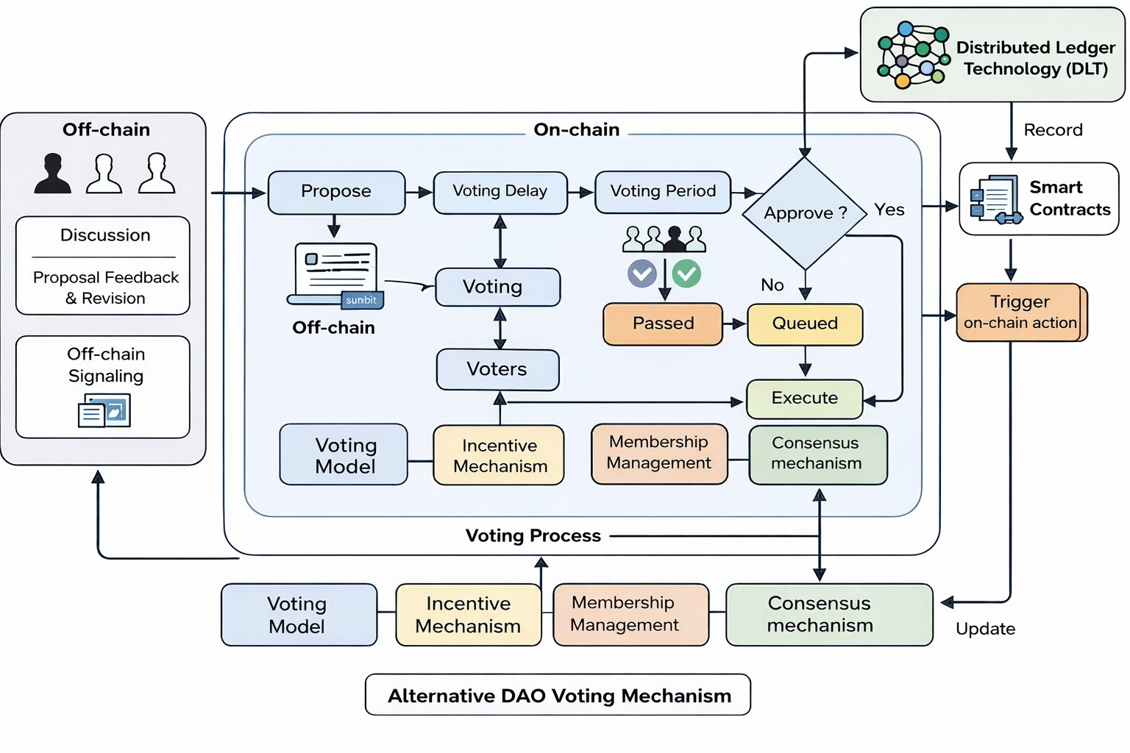
Built using blockchain technologies (such as Ethereum), smart contracts (Solidity), and Web3 frameworks, the system ensures secure, transparent, and tamper-proof governance. Off-chain indexing tools may be used to efficiently fetch and visualize blockchain data. Overall, the proposed system eliminates the need for centralized authority, enhances transparency, reduces manual intervention, and enables efficient, data-driven governance within decentralized organizations.

Figure 3.1 Workflow Diagram

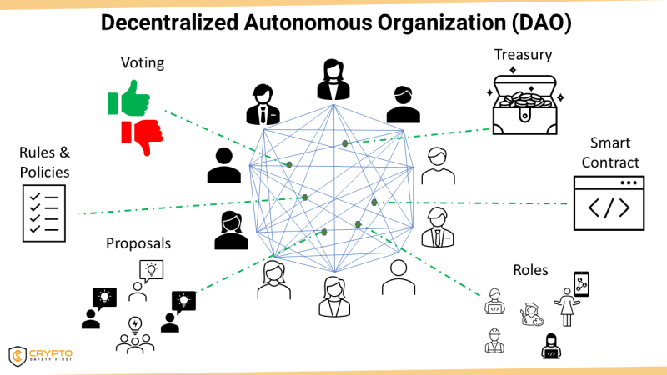

Figure 3.2 Faculty Worklog Workflow Diagram

3.2.1 Core System Architecture
The Decentralized Autonomous Organization (DAO) with On‑Chain Governance is designed using a decentralized, modular, and smart contract-driven architecture to ensure transparency, security, scalability, and trustless execution. Unlike traditional centralized systems, the DAO architecture distributes control across blockchain networks, where each component operates independently while interacting seamlessly through smart contracts and Web3 interfaces.

User Authentication and Wallet Integration Module: Instead of traditional login systems, users authenticate through cryptocurrency wallets (such as MetaMask).

Wallet addresses act as unique user identities.

Authentication is performed via cryptographic signatures rather than passwords.

This ensures secure, decentralized, and tamper-proof user access without relying on centralized servers.

Governance Token Management Module: This module manages the issuance, transfer, and tracking of governance tokens (ERC-20 standard).

Tokens represent voting power within the DAO.

Users can hold, transfer, or stake tokens to participate in governance.

Token balance directly influences proposal creation rights and voting weight.

Proposal Management Module: Enables users to create, view, and manage governance proposals.

Proposals are stored and executed through smart contracts.

Includes parameters such as proposal description, voting duration, quorum requirements, and execution logic.

Ensures immutability and transparency of all governance proposals.

Voting and Governance Module: This is the core module responsible for decentralized decision-making.

Token holders cast votes on proposals using their governance tokens.

Voting power is calculated based on token holdings (token-weighted voting).

Smart contracts automatically track votes, enforce deadlines, and determine outcomes.

Smart Contract Execution Module: Handles the automatic execution of approved proposals.

Once voting conditions (quorum and majority) are met, the contract executes actions without manual intervention.

Actions may include fund transfers, parameter updates, or governance changes.

Ensures trustless and deterministic execution of decisions.

On-Chain Data Storage and Integration Module: All critical data such as proposals, votes, and transactions are stored on the blockchain.

Ensures immutability, transparency, and auditability.

Off-chain indexing tools (e.g., subgraphs) may be used for efficient querying and visualization.

Seamless integration with frontend applications using Web3 libraries ensures real-time synchronization.

Decentralized Dashboard and Interface Module: A user-friendly frontend interface built using modern frameworks (e.g., React) interacts with smart contracts.

Displays proposals, voting status, token balances, and governance analytics.

Provides real-time updates using blockchain event listeners.

Enhances user experience while maintaining decentralization.

3.2.2 DAO Governance and Workflow Methodology
The Decentralized Autonomous Organization (DAO) with On‑Chain Governance streamlines the process of decentralized decision-making, proposal management, and transparent execution of actions without relying on a central authority. The methodology begins with user authentication through cryptocurrency wallet integration, where users connect their wallets (e.g., MetaMask) to access the platform. Once authenticated, users interact with the system based on their governance token holdings. Token holders can create proposals by submitting governance ideas or actions to be executed within the DAO. Each proposal is recorded on the blockchain through smart contracts, ensuring immutability and transparency.
After proposal creation, a predefined voting period begins during which eligible token holders can cast their votes. Voting power is determined by the number of governance tokens held by each participant. The system continuously tracks voting activity in real time, updating vote counts, quorum status, and participation metrics directly from the blockchain. Upon completion of the voting period, the smart contract automatically evaluates whether the proposal meets the required quorum and majority conditions. If approved, the proposal is executed automatically without manual intervention. All actions, including proposal creation, voting, and execution, are permanently stored on-chain, ensuring accountability and auditability. Event-driven notifications inform users about proposal updates, voting deadlines, and execution outcomes. This methodology eliminates manual processes, enhances transparency, reduces delays, and ensures fair and decentralized governance. Overall, it enables efficient organizational management through secure, automated, and trustless blockchain mechanisms.

3.2.3 Integration with Web3 Interfaces and Decentralized Systems
The DAO system emphasizes a user-friendly, responsive, and decentralized interface to ensure seamless interaction between users and blockchain-based smart contracts. The platform is designed as a decentralized application (DApp), where the frontend interacts directly with the blockchain using Web3 technologies. The user interface provides a comprehensive dashboard displaying active proposals, voting status, governance analytics, and token balances. Users can easily create proposals, participate in voting, and monitor DAO activities through an intuitive and well-structured layout.
The dashboard presents real-time data fetched from the blockchain, ensuring accuracy and transparency without relying on centralized servers. Developed using modern frontend frameworks such as React.js, the system supports dynamic rendering, responsive design, and cross-platform compatibility across desktops, tablets, and mobile devices. Web3 libraries (such as Ethers.js or Web3.js) are integrated to facilitate communication between the frontend and smart contracts deployed on the blockchain. The platform incorporates features such as real-time event listeners, transaction status updates, and interactive data visualization to enhance user experience. Search and filtering functionalities allow users to quickly access proposals, voting history, and governance records. Additionally, wallet integration ensures secure authentication and seamless transaction signing. By focusing on usability, responsiveness, and decentralization, the interface ensures that users with varying levels of technical expertise can effectively participate in governance activities. This promotes higher engagement, transparency, and adoption of the DAO system while maintaining the core principles of decentralization and trustless interaction.
3.3 PROPOSED METHODOLOGY
To overcome the limitations of centralized governance systems such as lack of transparency, delayed decision-making, and dependency on intermediaries, the proposed methodology for the Decentralized Autonomous Organization (DAO) with On‑Chain Governance leverages blockchain technology and smart contracts to enable secure, transparent, and automated organizational management. The system eliminates manual intervention and ensures that all governance activities are executed in a trustless and verifiable manner. The proposed methodology is built on a decentralized architecture, where users interact with the system through Web3-enabled interfaces connected directly to blockchain networks. Governance processes such as proposal creation, voting, and execution are handled by smart contracts, ensuring immutability and automation. The platform supports real-time updates through blockchain event listeners, enabling users to monitor governance activities as they occur. The system also incorporates token-based participation, where governance tokens determine user eligibility and voting power. This ensures fair and proportional decision-making. Additionally, the methodology integrates data analytics and visualization tools to provide insights into governance performance, participation trends, and system efficiency. Overall, the proposed methodology enhances transparency, reduces operational delays, ensures data integrity, and enables decentralized, data-driven governance suitable for modern digital organizations.

3.3.1 Governance Data Collection and Management
Sources: The DAO system relies on multiple decentralized and on-chain data sources to support governance operations. The primary data source is the blockchain ledger, which stores all governance-related transactions, including proposal creation, voting records, and execution results. Each transaction is uniquely identified by a transaction hash, ensuring traceability and immutability.
Another key data source is the governance token contract, which maintains information about token distribution, user balances, and voting power. This data is essential for determining user eligibility, calculating vote weight, and enforcing participation rules. Additionally, proposal data is stored within smart contracts, including details such as proposal ID, description, creator address, voting duration, quorum requirements, and execution logic.
Event logs generated by smart contracts serve as an important real-time data source. These logs capture activities such as proposal submissions, vote casting, and execution events, enabling frontend applications to display live updates. Off-chain indexing systems may also be used to structure and retrieve large datasets efficiently for analytics and visualization purposes.
Preprocessing Steps
Raw blockchain data is inherently complex and requires preprocessing to make it usable for analytics and user interfaces. Initially, transaction data is filtered and categorized based on event types such as proposals, votes, and executions. Unique identifiers such as wallet addresses and proposal IDs are standardized to maintain consistency across the system.
Data normalization techniques are applied to organize token balances, voting records, and participation metrics into structured formats. Event logs are ordered chronologically to support accurate tracking of governance activities and historical analysis. Additionally, redundant or irrelevant data is filtered out to improve performance and reduce computational overhead. To enhance usability, indexed data structures (such as subgraphs) are employed to enable efficient querying and faster data retrieval. This preprocessing layer ensures that the system operates on clean, structured, and meaningful datasets, forming a reliable foundation for real-time monitoring, analytics, and decision-making.
The extracted information is decoded from low-level formats into human-readable values and structured into organized fields such as proposal ID, voter address, vote weight, and timestamps. Wallet addresses are standardized to maintain consistency, and all events are arranged chronologically to accurately track the lifecycle of each proposal.
Further preprocessing involves cleaning and validating the data by removing duplicates, filtering invalid transactions, and ensuring integrity through blockchain verification. The processed data is then indexed and cached using off-chain solutions to improve query performance and enable fast retrieval for dashboards. Aggregation techniques are applied to compute governance metrics such as participation rates, voting outcomes, and proposal success ratios. Finally, real-time synchronization mechanisms ensure that any new blockchain activity is instantly reflected in the system, resulting in a clean, structured, and analysis-ready dataset for efficient DAO governance monitoring and decision-making.
3.3.2 Core Functional Modules
The Decentralized Autonomous Organization (DAO) with On‑Chain Governance integrates multiple functional modules, each designed to support decentralized decision-making, transparency, and automated execution through blockchain technology:

Module 1: Wallet Authentication and User Identity
Enables users to securely access the system through cryptocurrency wallet integration (e.g., MetaMask). Instead of traditional usernames and passwords, wallet addresses act as unique identifiers. Authentication is performed using cryptographic signatures, ensuring secure and decentralized user access without reliance on a central authority management.

Module 2: Governance Token Management
Allows and manages the creation, distribution, and tracking of governance tokens within the DAO. These tokens represent voting power and participation rights. The module ensures that token balances are accurately maintained on-chain and directly influence proposal eligibility and voting weight, enabling fair and proportional governance functionality.

Module 3: Proposal Creation and Management
Allows eligible users to create governance proposals by defining objectives, parameters, and execution logic. Each proposal is recorded on the blockchain through smart contracts, ensuring immutability and transparency. Users can view all active, pending, and executed proposals along with their details and status.

Module 4: Voting and Decision-Making System
Differentiates system functionality based on user roles. Enables token holders to participate in voting on proposals. Voting power is calculated based on token holdings, and all votes are securely recorded on-chain. The system enforces voting deadlines, quorum requirements, and majority rules through smart contracts, ensuring fair and tamper-proof decision-making.
- Admin Can manage faculty, subjects, and work allocation.
- Faculty Can view their allocated subjects, update progress, and track workload. RBAC ensures secure access to system features and maintains data
Module 5: Smart Contract Execution Module:
Automatically executes approved proposals once predefined conditions such as quorum and majority are met. Actions such as fund transfers, governance updates, or rule changes are carried out without manual intervention, ensuring trustless and autonomous operation of the DAO.
Module 6: Role-Based Governance and Access Control:
Defines participation levels based on token ownership rather than fixed roles.
- Token Holders Can vote on proposals and participate in governance.
- Proposers Users with sufficient tokens can create proposals.
This decentralized access control model ensures fairness while preventing unauthorized actions.
Module 7: Governance Analytics and Reporting
Provides insights into DAO activities through dashboards displaying proposal statistics, voting participation rates, quorum status, and execution history. Data visualization tools help users understand governance trends and make informed decisions

Module 8: Workload Analysis and Reporting
Generates visual and tabular summaries of faculty workloads, displaying allocation trends, completed tasks, and pending work. This module assists administrators in reviewing overall department performance and making data-driven decisions for future task distribution.

3.3.3 System Development
The DAO with On‑Chain Governance system is implemented using a combination of blockchain technologies and modern web development frameworks to ensure decentralization, scalability, security, and high performance across all modules
- Frontend (React.js / Web3 Interface): The frontend of the DAO system is developed using modern frameworks such as React.js, providing a responsive and user-friendly decentralized application (DApp) interface. It includes interactive dashboards where users can view proposals, participate in voting, track governance activities, and monitor token balances. Web3 integration enables seamless interaction with blockchain networks through wallet connections (e.g., MetaMask). Dynamic UI components support real-time updates, proposal filtering, governance analytics, and visualization of voting results, ensuring an intuitive and transparent user experience.
- Smart Contracts (Solidity): The core logic of the system is implemented using Solidity-based smart contracts deployed on blockchain platforms such as Ethereum. These smart contracts handle critical functionalities including proposal creation, voting mechanisms, quorum validation, and automatic execution of approved proposals. Since the logic is deployed on-chain, it ensures immutability, transparency, and trustless operation without reliance on centralized servers.
- Blockchain Network (Ethereum): The system operates on a blockchain network such as Ethereum, which acts as the decentralized data layer. All governance activities including proposals, votes, and execution results are permanently recorded on-chain. This ensures data integrity, auditability, and resistance to tampering. The blockchain also enables distributed consensus, eliminating the need for a central authority to validate decisions.
- Web3 APIs and Integration (Ethers.js / Web3.js): Web3 libraries act as the communication bridge between the frontend and the blockchain. They are used to interact with smart contracts, send transactions, fetch on-chain data, and listen to contract events. These APIs enable functionalities such as proposal submission, vote casting, transaction tracking, and real-time updates. The integration ensures seamless and secure interaction between users and the decentralized backend.
- Off-Chain Storage and Indexing (Optional Layer): To improve performance and enable efficient data retrieval, off-chain indexing solutions such as The Graph can be used. These systems structure blockchain data into queryable formats, allowing fast access to proposal histories, voting records, and analytics without repeatedly querying the blockchain. This enhances user experience while maintaining on-chain data integrity.

3.3.4 Feature Integration and Automation
Once the core modules of the DAO system are implemented and smart contract structures are deployed, several automated features are integrated to enhance governance efficiency, eliminate manual intervention, and ensure seamless decentralized operations:
- Automated Proposal Lifecycle Management: All governance activities are automatically managed through smart contracts. When a proposal is created, the system initiates the voting phase with predefined parameters such as voting duration and quorum requirements. The entire lifecycle from proposal creation to voting and final execution is handled autonomously without human intervention, ensuring transparency and consistency.
- Token-Based Role and Access Control: Access and participation within the DAO are dynamically controlled based on governance token ownership. Users holding tokens can participate in voting, while those meeting minimum token thresholds can create proposals. This automated mechanism replaces traditional role-based systems.
- ·Real-Time Voting and Event Tracking: All voting activities are recorded on-chain and reflected instantly through blockchain event listeners. Users can view live updates of vote counts, participation levels, and proposal status. This real-time synchronization ensures that governance data is always accurate, transparent, and tamper-proof.
- Automated Execution of Approved Proposals: Once a proposal satisfies quorum and majority conditions, the smart contract automatically executes the defined actions. This may include fund transfers, governance parameter updates, or protocol changes.
- Governance Analytics and Visualization: The system automatically aggregates on-chain data to generate governance insights such as voting participation rates, proposal success ratios, and token distribution patterns. These analytics are displayed through interactive dashboards, enabling users to understand governance trends.
3.3.5 Real-time Workflow Automation
Real-time workflow automation is a fundamental aspect of the DAO with On‑Chain Governance system, enabling seamless decentralized coordination and instant execution of governance activities without manual intervention. The frontend decentralized application (DApp), built using modern frameworks such as React.js, utilizes event listeners and Web3 integration to monitor user interactions such as proposal creation, vote casting, and transaction submissions. Each user action triggers a blockchain transaction, which is processed by smart contracts deployed on the network, ensuring secure validation and immutable recording of governance operations.
The automation is primarily driven by smart contract logic, which handles the entire governance lifecycle, including proposal activation, voting duration management, quorum verification, and final execution. Blockchain event listeners continuously track contract events such as proposal creation, vote updates, and execution results, allowing the frontend to reflect real-time changes instantly. Additionally, time-dependent conditions such as voting deadlines and execution triggers are enforced automatically by the smart contract rules, eliminating the need for centralized schedulers or manual monitoring.
The system dashboard dynamically updates using real-time blockchain data, providing users with accurate insights into proposal status, voting participation, and governance outcomes. This automated workflow ensures continuous synchronization between on-chain data and user interfaces, significantly enhancing transparency, reducing delays, and enabling efficient decentralized decision-making. Overall, the automation framework transforms governance into a self-executing, transparent, and trustless process aligned with the core principles of blockchain technology.

3.3.6 Security and Scalability
Security and scalability are critical aspects of the DAO with On‑Chain Governance system, ensuring reliable, tamper-proof, and efficient decentralized operations across the network.
Security Measures
The system leverages blockchain technology to provide inherent security through decentralization, cryptographic validation, and immutability of data. Instead of traditional Role-Based Access Control, access and participation are governed through wallet-based authentication and governance token ownership. Users interact with the system via secure cryptographic signatures, eliminating the need for passwords and reducing the risk of credential-based attacks. Smart contracts enforce strict validation rules for proposal creation, voting, and execution, preventing unauthorized actions or manipulation. Additionally, all transactions are verified by the blockchain network, ensuring transparency and resistance to tampering. Security best practices such as smart contract auditing, reentrancy protection, and input validation are incorporated to safeguard against common vulnerabilities.
Scalability Features
The DAO system is designed to operate efficiently on decentralized networks while supporting future growth and increasing user participation. Scalability is achieved through optimized smart contract design, minimizing gas consumption and reducing computational overhead. Layer-2 solutions and sidechains can be integrated to handle high transaction volumes and improve throughput. Off-chain indexing and data retrieval mechanisms (such as The Graph) are used to enhance performance and reduce direct blockchain queries. The modular architecture allows seamless addition of new governance features, analytics tools, or integration with other decentralized applications without disrupting existing functionality. This ensures that the system remains adaptable, efficient, and capable of scaling with the expanding DAO ecosystem.

3.4 PERFORMANCE ENHANCEMENT

3.4.1 Database Optimization

Database optimization in the DAO system focuses on efficient handling of blockchain and off-chain data to ensure fast access and smooth user interaction. Since on-chain data retrieval can be time-consuming and resource-intensive, the system utilizes off-chain indexing solutions such as The Graph to structure and store governance data including proposals, votes, and execution history. Indexed data enables rapid querying and reduces the need for repeated direct blockchain calls. Additionally, caching mechanisms are implemented to store frequently accessed data such as active proposals, voting results, and user token balances, significantly improving response time. Data filtering and selective retrieval techniques are applied to fetch only relevant information, ensuring optimized performance and efficient rendering in the decentralized application (DApp) interface.

3.4.2 Load Balancing

Load balancing in the DAO system is achieved through decentralized infrastructure and distributed network participation rather than traditional centralized servers. Blockchain networks inherently distribute transaction processing across multiple nodes, ensuring that no single point becomes a bottleneck. For the frontend and off-chain services, requests are managed across multiple nodes or decentralized hosting platforms (such as IPFS or cloud-based edge networks) to ensure high availability and reduced latency. This distributed approach ensures that even during peak governance activities such as large-scale voting or proposal execution the system maintains consistent performance, fault tolerance, and uninterrupted accessibility for all users.

3.4.3 Asynchronous Processing

Asynchronous processing is a fundamental feature of blockchain-based systems, enabling non-blocking execution of operations within the DAO. User actions such as proposal submission or vote casting are executed as transactions that are processed asynchronously by the blockchain network. While transactions are being validated and confirmed, the frontend continues to operate smoothly without delays. Event-driven mechanisms and blockchain listeners update the system in real time once transactions are confirmed. Additionally, background processes such as data indexing, analytics computation, and notification updates are handled asynchronously, ensuring high system responsiveness, reduced latency, and an enhanced user experience.

CHAPTER 4
PROPOSED WORK MODULE

This Chapter Presents the Proposed Design and Methodology for Developing the Decentralized Autonomous Organization (DAO) With On‑Chain Governance Using Blockchain Technology and Web3 Frameworks. The System Is Designed to Enable Decentralized Decision‑making Without Relying on Central Authorities, Ensuring Transparency, Security, And Trust Among Participants.
Unlike Traditional Systems, This Platform Operates Through Smart Contracts That Automatically Enforce Governance Rules. All Activities Such as Proposal Creation, Voting, And Execution Are Recorded on the Blockchain, Making the System Tamper‑proof And Auditable. The Use of Ethereum‑based Smart Contracts Ensures Reliability, While the Integration with Web3 Technologies Enables Seamless User Interaction Through Decentralized Interfaces. The Proposed System Not Only Improves Governance Efficiency but Also Introduces Trustless Collaboration, Where Participants Can Interact Without Needing to Trust a Central Entity. The Architecture Supports Scalability, Security, And Modularity, Making It Suitable for Real‑world DAO Implementations.
4.1 PROPOSED WORK
The DAO With On‑Chain Governance System Is Designed as A Modular and Decentralized Application, Where Each Module Handles a Specific Governance Function. The Modules Are Interconnected Through Smart Contracts and Blockchain Transactions.
- User Authentication and Wallet Integration Module - This Module Uses Blockchain Wallets for Authentication Instead of Traditional Login Systems. Users Connect Their Wallets (e.g., MetaMask) To Access the Platform. Authentication Is Done Through Cryptographic Signatures, Ensuring Secure and Decentralized Identity Verification Without Storing Sensitive Credentials.
- Governance Token Management Module - This Module Manages the Creation and Distribution of Governance Tokens Using ERC‑20 Standards. These Tokens Represent Voting Power and Determine the Influence of Each Participant in the DAO. The Module Also Handles Token Transfers, Balance Tracking, And Optional Delegation Mechanisms, Enabling Users to Delegate Voting Power to Other Members.
- Proposal Creation and Management Module - This Module Enables Users to Create Proposals That Define Governance Actions. Each Proposal Includes Metadata Such as Description, Voting Duration, Execution Logic, And Target Contract Interaction. The System Ensures That Once a Proposal Is Created, It Cannot Be Modified, Maintaining Integrity and Preventing Manipulation.
- Voting Mechanism Module - This Module Implements Token‑based Voting Where Users Vote Based on Their Token Holdings. The Voting Process Includes Time‑bound Voting Windows, Snapshot Mechanisms, And Automatic Vote Counting. Advanced Features Such as Quorum Requirements and Majority Thresholds Ensure That Decisions Reflect Collective Consensus.
- Proposal Execution Module - This Module Automatically Executes Approved Proposals Using Smart Contracts. Execution Occurs Only When Defined Conditions Such as Minimum Quorum and Majority Votes Are Met. The Automation Eliminates Human Intervention and Ensures Accuracy.
- Treasury Management Module - This Module Handles DAO Funds Securely. Funds Are Stored in Smart Contracts and Can Only Be Accessed Through Approved Proposals. Multi‑step Validation and Governance Approval Ensure That Financial Transactions Are Transparent and Secure.
- On‑Chain Data and Record Management Module - This Module Stores All Governance Activities on the Blockchain, Including Proposals, Votes, And Transactions.
4.2 METHODOLOGY OF THE PROPOSED WORK
4.2.1 User Authentication and Wallet Integration Module
This Module Uses Decentralized Authentication Through Blockchain Wallets. Users Authenticate by Signing Messages Using Their Private Keys, Ensuring That No Passwords Are Stored or Transmitted. Web3 Libraries Such as Ethers.js Facilitate Communication Between the Frontend and Smart Contracts. The System Also Implements Network Verification to Ensure Users Are Connected to the Correct Blockchain Network. Security Is Further Enhanced Through Nonce-based Authentication and Signature Verification to Prevent Replay Attacks.
Findings
- Eliminates Centralized Authentication Risks
- Provides Strong Cryptographic Security
- Enhances User Privacy and Control Over Identity
4.2.2 Governance Token Management Module
This Module Implements Token-based Governance Using ERC-20 Smart Contracts. Tokens Are Minted and Distributed Based on Predefined Rules. The Module Tracks Token Balances in Real-time And Ensures Accurate Representation of Voting Power. Optional Governance Extensions Such as Token Locking and Staking Can Be Integrated to Enhance Participation. Efficient Storage and Gas Optimization Techniques Are Used to Minimize Transaction Costs.
Findings
- Enables Fair and Transparent Governance Participation
- Supports Scalable and Flexible Token Distribution
- Improves System Efficiency Through Optimized Smart Contracts

4.2.3 Proposal Creation and Management Module
This Module Allows Users to Create Structured Governance Proposals. Each Proposal Includes Parameters Such as Title, Description, Execution Data, And Voting Deadline. The System Uses Smart Contracts to Validate Proposal Creation Conditions, Prevent Spam, And Ensure Only Eligible Users Can Submit Proposals. Proposals Are Assigned Unique Identifiers and Stored Permanently on the Blockchain.
Findings
- Ensures Structured and Transparent Governance
- Prevents Unauthorized or Malicious Proposal Creation
- Enhances Clarity in Decision-making Processes
4.2.4 Voting Mechanism Module
The Voting Mechanism Uses Snapshot-based Voting to Prevent Manipulation Due To Token Transfers During Voting. Votes Are Recorded On-chain, And Results Are Computed Automatically. The System Ensures That Each Token Can Be Used Only Once Per Proposal.
Additional Safeguards Such as Voting Deadlines and Participation Thresholds Improve Governance Reliability.
Findings
- Prevents Double Voting and Token Manipulation
- Ensures Fair and Transparent Voting Outcomes
- Strengthens Trust in Governance Processes
4.2.5 Proposal Execution Module
This Module Automates the Execution of Approved Proposals by Calling Smart Contract Functions. Execution Conditions Are Verified Before Triggering Actions. The System Prevents Duplicate Execution and Ensures That Only Successful Proposals Are Executed. Gas Optimization Strategies Are Used to Reduce Execution Costs.
Findings
- Ensures Reliable And Accurate Execution
- Eliminates Manual Errors and Delays
- Improves System Efficiency Through Automation
4.2.6 Treasury Management Module
The Treasury Module Uses Secure Smart Contracts to Store and Manage Funds. Access To Funds Is Controlled Through Governance Voting. The System Implements Safeguards Such as Access Restrictions, Validation Checks, And Event Logging to Ensure Transparency. All Transactions Are Publicly Verifiable on The Blockchain.
Findings
- Provides Secure and Transparent Fund Management
- Prevents Unauthorized Transactions
- Enhances Financial Accountability
4.2.7 On-Chain Data and Record Management Module
This Module Stores All Governance Data on the Blockchain, Ensuring Immutability and Transparency. Efficient Data Structures Such as Mappings and Event Logs Are Used to Optimize Storage and Retrieval. The System Allows Easy Access to Historical Data for Analysis, Auditing, And Verification.
Findings
- Ensures Data Integrity and Permanence
- Enables Transparent and Auditable Governance

CHAPTER 5
RESULTS AND DISCUSSION
5.1 RESULTS
The proposed Decentralized Autonomous Organization (DAO) with On‑Chain Governance system was extensively evaluated across multiple operational and technical dimensions to assess its efficiency, scalability, transparency, and robustness in decentralized governance. The system successfully demonstrates a transition from traditional centralized control mechanisms to a fully autonomous, blockchain-driven governance model where all processes are enforced through smart contracts. The implementation integrates core components such as wallet-based authentication, proposal lifecycle management, token-weighted voting, automated execution, and governance analytics. These modules were tested under various scenarios including multiple concurrent proposals, high voting participation, and real-time updates. The results confirm that the system maintains consistency, reliability, and transparency across all operations.
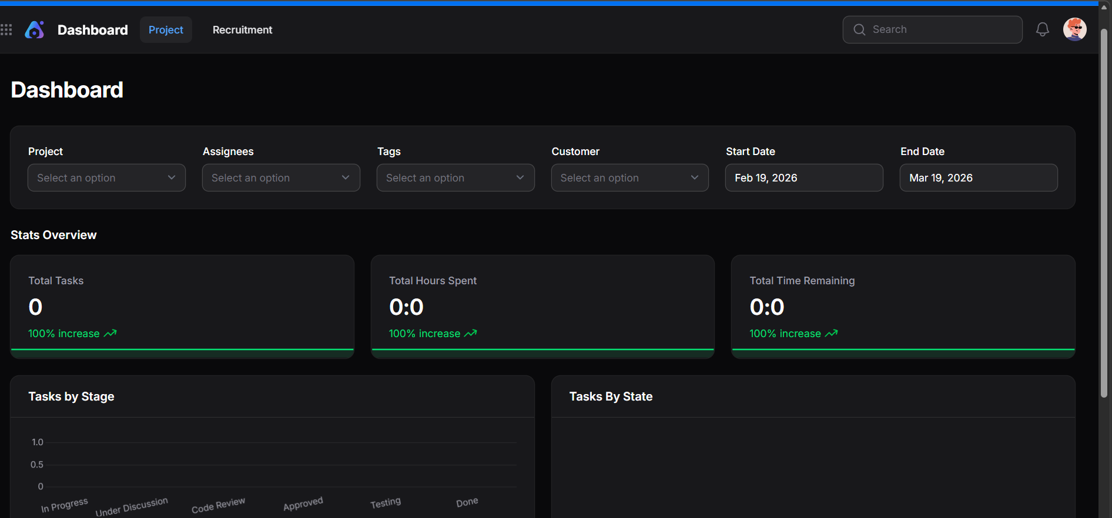

Figure 5.1 Home page

5.1.1 Wallet Authentication and User Management
The wallet authentication module replaces traditional username-password systems with cryptographic identity verification using blockchain wallets. Users authenticate by signing transactions, ensuring a secure and decentralized access mechanism. This approach significantly enhances security by eliminating centralized credential storage, thereby reducing the risk of data breaches and unauthorized access. Each user is uniquely identified by their wallet address, which acts as a persistent and verifiable identity within the DAO ecosystem. Additionally, the system supports seamless integration with Web3 providers, enabling smooth onboarding of users without complex registration processes. The authentication flow is efficient and ensures that only legitimate users can interact with governance functions such as proposal creation and voting.
Key Outcomes
- Highly secure authentication using cryptographic signatures
- Elimination of password management and related vulnerabilities
- Simplified and seamless user onboarding experience
- Decentralized identity management without third-party control
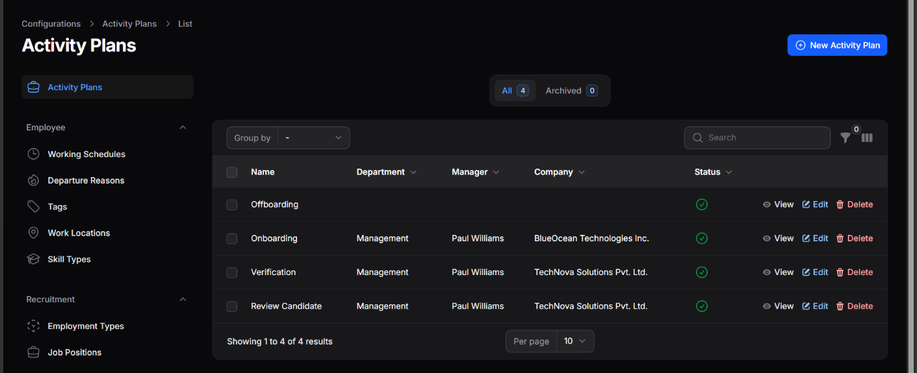

Figure 5.2 DAO Governance Dashboard Interface

5.1.2 Proposal Creation and Management
The proposal management module forms the backbone of the governance system. Users with sufficient governance tokens can create proposals that define specific actions such as fund transfers, protocol upgrades, or policy changes. Each proposal undergoes a structured lifecycle consisting of creation, validation, activation, voting, and execution phases. Smart contracts ensure that proposals meet predefined criteria before being accepted into the system. Once created, proposals are immutable and publicly visible, ensuring transparency. The system also supports metadata storage and structured proposal descriptions, allowing users to clearly understand the intent and implications of each proposal. Multiple proposals can coexist, and the system efficiently manages their states without conflicts.

Observations
      - Transparent and immutable proposal records
      - Clearly defined proposal lifecycle stage
      - Improved governance clarity and accountability
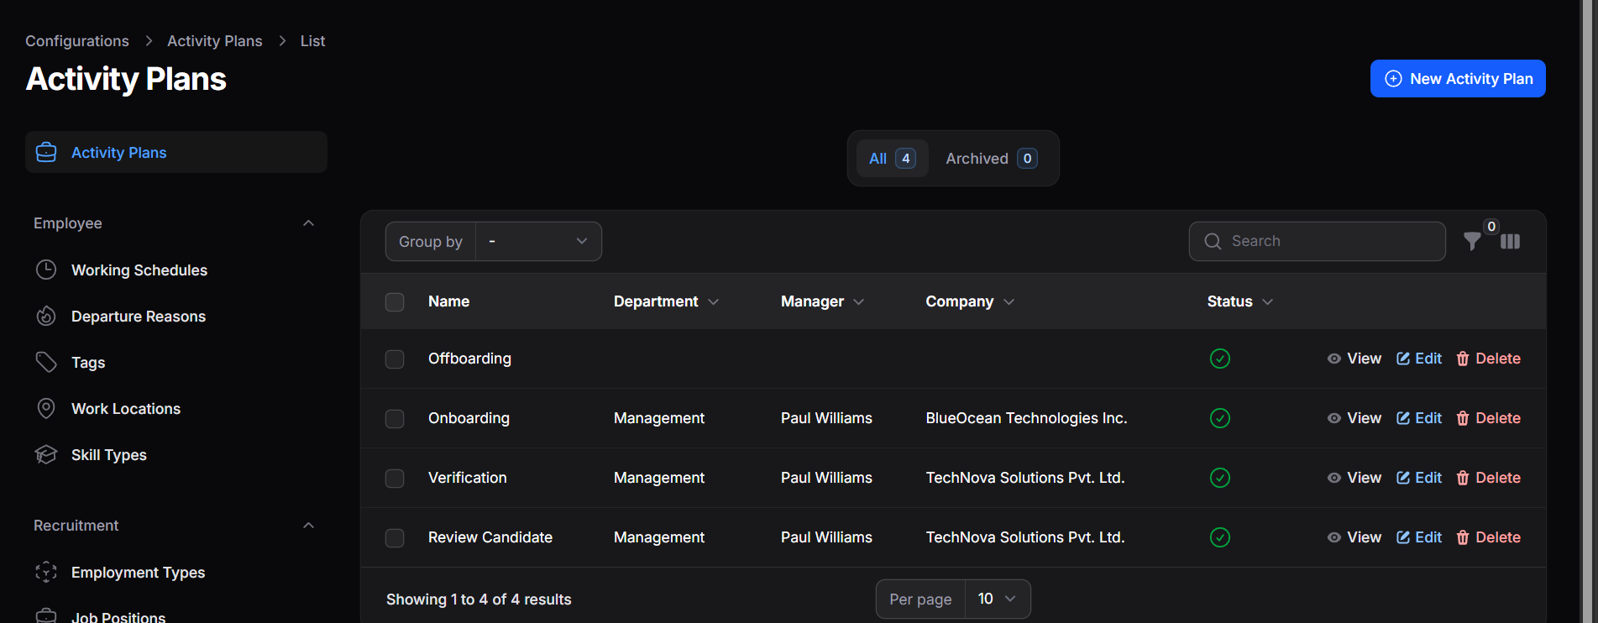
Figure 5.3 Proposal / Activity Management Interface

5.1.3 Voting Mechanism and Governance Participation
The voting mechanism enables decentralized participation where token holders exercise voting power proportional to their holdings. This ensures fair representation and aligns decision-making with stakeholder interests. The system enforces strict voting rules including time-bound voting windows, quorum thresholds, and majority requirements. Smart contracts automatically validate votes and prevent issues such as double voting or unauthorized participation. Real-time updates allow users to track voting progress, participation rates, and expected outcomes. This enhances engagement and ensures transparency throughout the voting process. Additionally, the system supports extensibility for advanced voting mechanisms such as delegated voting or quadratic voting, making it adaptable for future enhancements.
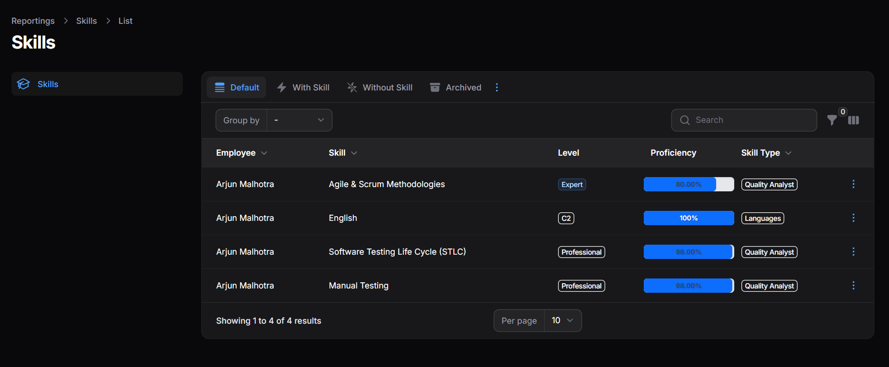

Figure 5.4 DAO Member Skills and Contribution Tracking Interface
Key outcomes
      - Fair and transparent token-based voting
      - Automated enforcement of governance rules
      - Real-time visibility into voting activity.

5.1.4 Smart Contract Execution and Automation
One of the most significant achievements of the system is the automation of governance execution through smart contracts. Once a proposal satisfies quorum and majority conditions, the execution is triggered automatically without any human intervention. This ensures that decisions are implemented exactly as approved, eliminating delays and reducing the risk of manipulation.
The execution logic is deterministic, meaning the outcome is predictable and consistent across all nodes in the network. The system also incorporates safeguards to prevent premature or unauthorized execution, ensuring that only valid proposals are executed. This enhances trust and reliability in the governance process.
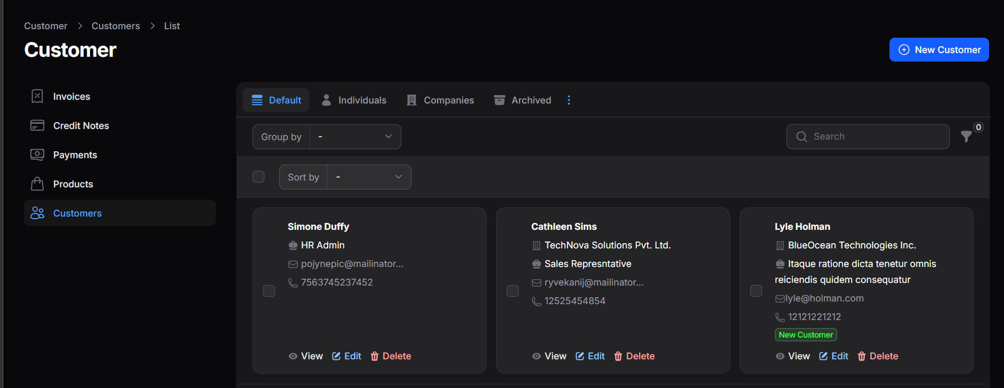

Figure 5.5 DAO Participant / Stakeholder Management Interface
Result highlights
- Provided a unified platform for managing all subjects in one view.
- Simplified addition and modification of subject details.
- Fully automated execution of approved proposals
- Elimination of manual dependency and delays
- High reliability and deterministic outcomes
- Secure and validated execution process
- Improved data consistency and reduced administrative workload

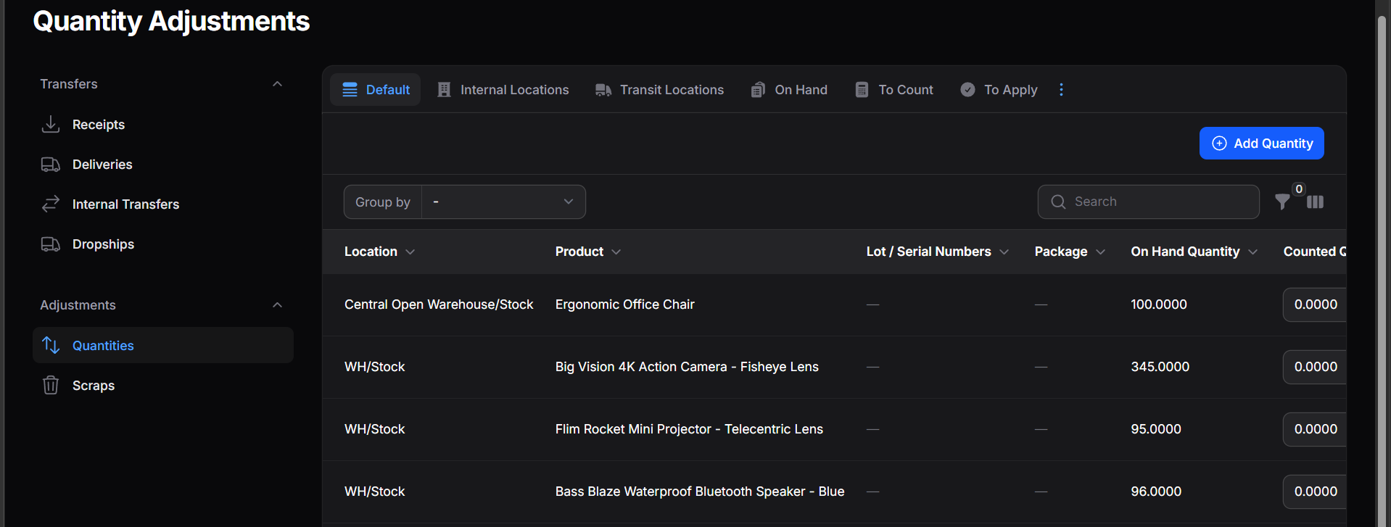

Figure 5.6 DAO Roles and Permission Management Interface
5.1.5 Governance Dashboard and User Interface Performance
The governance dashboard provides a comprehensive and interactive interface for users to monitor all DAO activities. It displays proposal details, voting status, participation metrics, and execution results in real time. The frontend is designed to dynamically update using blockchain event listeners, ensuring synchronization with on-chain data. This allows users to receive instant feedback on their actions and stay informed about governance activities.
The user interface emphasizes simplicity and usability, making it accessible even to users with limited technical knowledge. Visualization tools such as charts and graphs provide meaningful insights into governance trends and participation patterns.

Key Outcomes

Real-time synchronization with blockchain data

Interactive and user-friendly interface

Improved accessibility and user engagement
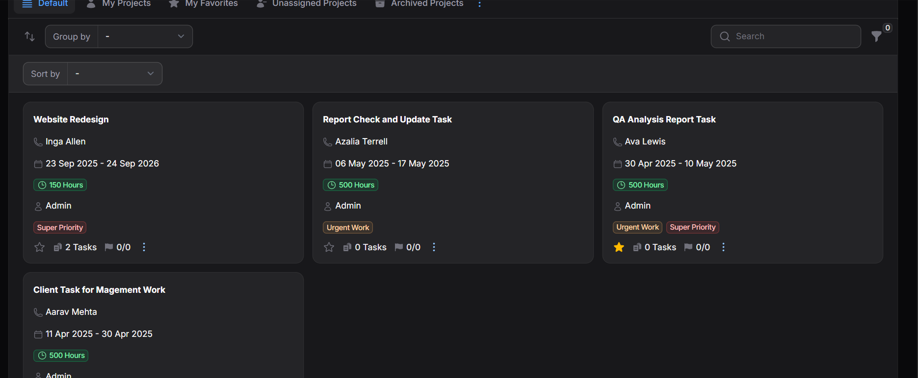
Figure 5.7 Add a new project module interface

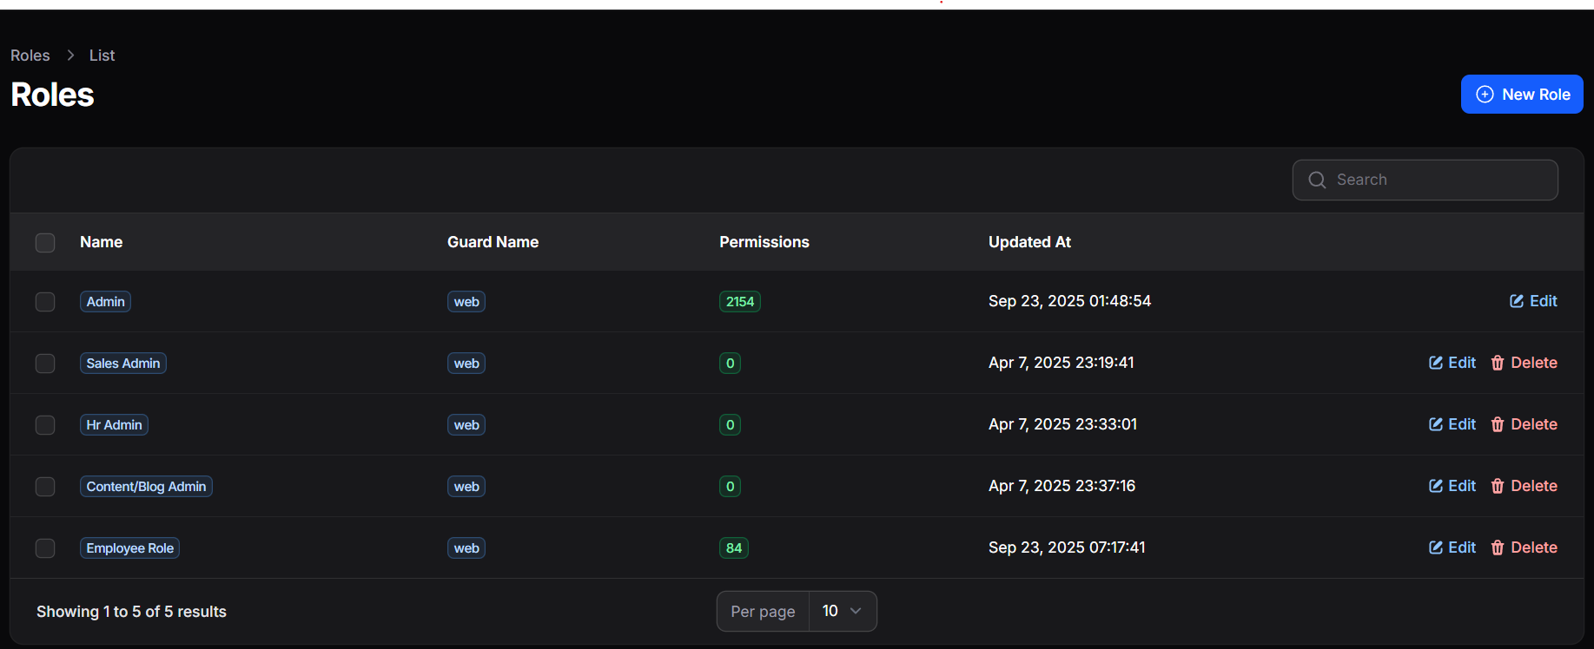

Figure 5.8 Role Announcement interface

From a usability perspective, the interface follows a clean and intuitive design, making it accessible to both technical and non-technical users. Interactive components such as filters, search options, and categorized views allow users to navigate large datasets efficiently. Visualization tools including charts, graphs, and progress indicators transform complex governance data into easily understandable insights. These visual elements help identify trends such as voting patterns, proposal success rates, and member participation over time.
Furthermore, the dashboard supports analytical decision-making by enabling users to compare historical governance data, evaluate proposal performance, and identify active contributors within the DAO. This not only improves transparency but also strengthens accountability among participants. Overall, the governance dashboard acts as a central intelligence layer of the DAO, bridging the gap between blockchain data and user interaction while promoting efficient, transparent, and data-driven decentralized governance.

DISCUSSION
The DAO with on‑Chain Governance system demonstrates a significant improvement over traditional governance models by introducing automation, transparency, and decentralization. The integration of smart contracts ensures that all governance processes are executed without bias or manual intervention. The system effectively reduces operational inefficiencies by eliminating intermediaries and enabling direct participation from stakeholders. The use of blockchain technology ensures data integrity and prevents unauthorized modifications, making the system highly secure and trustworthy. Moreover, the scalability of the architecture allows the system to handle increasing user participation and governance complexity. The modular design ensures that new features can be integrated without disrupting existing functionality. Overall, the system provides a robust framework for decentralized governance, making it suitable for real-world applications such as DAOs, decentralized finance (DeFi), and community-driven platforms.

Practical Interpretation of Results

From a practical perspective, the system successfully demonstrates real-time governance execution with minimal latency. Users can create proposals, cast votes, and observe outcomes seamlessly through the interface. The automation of governance processes reduces administrative overhead and ensures consistent execution of decisions. The system’s ability to handle multiple operations simultaneously without performance degradation highlights its efficiency and reliability. The real-time synchronization between blockchain and frontend ensures that users always have access to the latest information, improving decision-making and user experience.

Comparison with Traditional Systems
Traditional governance systems are often centralized, slow, and prone to errors due to manual processes and lack of transparency. In contrast, the DAO system provides:
- Automated governance lifecycle
- Immutable and transparent data storage
- Decentralized participation without intermediaries
- Instant execution of approved decisions
Conclusion of Comparison
The Decentralized Autonomous Organization (DAO) system with on-chain governance significantly outperforms traditional centralized governance systems by introducing a highly secure, transparent, and automated decision-making framework. In conventional systems, governance processes often rely on intermediaries, manual approvals, and off-chain record keeping, which can lead to delays, lack of transparency, and potential manipulation of data. In contrast, the DAO system leverages blockchain technology to store all proposals, voting activities, and execution records immutably on-chain, ensuring that every action is publicly verifiable and tamper-proof.

Furthermore, the use of smart contracts automates the entire governance lifecycle—from proposal creation to voting and execution—eliminating the need for manual intervention and reducing operational inefficiencies. Token-based voting mechanisms ensure fair participation by stakeholders, where voting power is proportionate and clearly defined. This promotes decentralized control and removes reliance on a central authority, thereby increasing trust among participants.
Additionally, the DAO framework enhances efficiency by enabling real-time proposal tracking, instant vote counting, and automatic execution of approved decisions. It also improves accountability, as all actions are permanently recorded on the blockchain and can be audited at any time. Compared to traditional governance models, the DAO system provides scalable

SIGNIFICANCE, STRENGTHS, AND LIMITATIONS

Significance of the DAO System

The DAO system represents a paradigm shift in organizational governance by leveraging blockchain technology to enable decentralized decision-making. It removes the need for centralized authorities and empowers stakeholders to participate directly in governance processes. This approach enhances transparency, accountability, and trust, making it highly relevant for modern digital ecosystems. The system also serves as a foundation for future decentralized applications and governance models.

Strengths of the System

Decentralization Eliminates single points of failure and control

Transparency All activities are publicly verifiable on the blockchain

Automation Smart contracts handle governance processes efficiently

Security Cryptographic mechanisms ensure data integrity

Scalability Supports integration with advanced blockchain technologies

Flexibility Modular design allows easy feature expansion

Limitations

M Gas Fees Transaction costs may vary based on network conditions

Scalability Constraints Public blockchains may face congestion

Technical Complexity Requires knowledge of blockchain and smart contracts

User Adoption Barrier New users may find Web3 interaction complex.

COST-BENEFIT ANALYSIS
Though the Worklog and Tracking Portal may involve initial setup costs, including development and staff training, it ensures long-term efficiency through automation, accurate record tracking, and improved departmental transparency. The overall benefits outweigh the recurring maintenance expenses.
Cost breakdown and benefits for system implementation:

Cost Factor | Estimated cost (INR) | Cost Benefits | Applicable Sectors | Key outcomes
Smart Contract Development & Deployment | ₹1,00,000 | Secure and automated governance through blockchain-based smart contracts | Blockchain Startups, DAOs, DeFi Platforms | Transparent decision-making and elimination of centralized control
Blockchain Network & Gas Fees | ₹25,000 | Enables on-chain transactions, proposal execution | Web3 Applications, Crypto Communities | Reliable and tamper-proof transaction processing
Frontend DApp Development | ₹25,000 | Interactive user interface for proposal creation, voting, and governance tracking | Decentralized Platforms | Enhanced user experience and real-time governance interaction
Hosting & Decentralized Storage (IPFS) | ₹30,000 | Decentralized storage for metadata, proposals, and UI hosting | DAO Ecosystems | High availability, data integrity, and censorship resistance
Data Backup  and Security Implementation | ₹6,000 | Protects institutional and faculty data from loss or unauthorized  access | Educational Institutions, Administrative Departments | Reduced vulnerabilities and improved trustworthiness, Increased adoption and effective participation in governance

CHAPTER 6
CONCLUSION AND SUGGESTIONS FOR FUTURE WORK
6.1 CONCLUSION
The Proposed Decentralized Autonomous Organization (DAO) With On-Chain Governance System Effectively Demonstrates How Blockchain Technology Can Be Utilized to Transform Traditional Organizational Governance into A Fully Decentralized, Transparent, And Trustless Model. The System Eliminates the Dependency on Central Authorities by Replacing Manual and Hierarchical Decision-making Processes with Smart Contract-based Automation. All Governance Activities, Including Proposal Creation, Voting, And Execution, Are Managed Through Immutable Blockchain Transactions, Ensuring Transparency, Security, And Accountability.
The Implementation of Modular Smart Contracts Provides a Well-structured Architecture Where Each Component Such as Governance Logic, Token Management, And Treasury Operations Functions Independently Yet Collaboratively. This Modular Design Enhances Maintainability, Scalability, And Future Extensibility of the System. The Voting Mechanism, Based on Token-weighted Participation and Snapshot Techniques, Ensures Fair and Tamper-proof Decision-making. It Prevents Issues Such as Double Voting and Token Manipulation, Thereby Strengthening the Integrity of Governance Processes. The Use of Time-bound Voting Windows and Quorum Validation Further Ensures That Decisions Reflect Collective Consensus The Treasury Management System Adds Another Layer of Security by Ensuring That Funds Are Controlled Through Governance Decisions Rather Than Individual Authority. Every Financial Transaction Is Subject to Approval Through Voting. From A Technical Perspective, The Integration of Web3 Technologies Enables Seamless Interaction Between Users and Blockchain Networks Through Wallet-based Authentication. This Removes the Need for Traditional Credential Systems and Enhances User Privacy and Security.
Furthermore, The System Ensures High Data Integrity and Auditability by Storing All Records On-chain. Every Action Is Traceable and Verifiable, Making the System Highly Reliable for Organizational Use Cases. Gas Optimization Strategies and Efficient Data Structures Improve the Overall Performance and Practical Deploy ability Of the System. In Addition, The Project Demonstrates the Feasibility of Implementing Real-world DAO Models That Can Be Applied in Various Domains Such as Finance, Governance, And Collaborative Platforms. It Highlights the Potential of Blockchain Technology to Enable Decentralized Collaboration Without the Need for Intermediaries. Overall, The Project Successfully Achieves Its Objective of Designing and Implementing a Secure, Transparent, And Efficient DAO System. It Showcases How Decentralized Governance Can Improve Decision-making Efficiency, Reduce Operational Complexity, And Establish Trust Among Participants in a Digital Ecosystem.
6.2 SUGGESTIONS FOR FUTURE WORK
While The Current Implementation Successfully Achieves the Core Objectives, There Are Several Opportunities to Enhance the System Further in Terms of Scalability, Functionality, Security, And User Experience.
6.2.1 Integration with Layer-2 Scaling Solutions
Future Enhancements Can Include Integration with Layer-2 Scaling Technologies Such as Rollups (Optimistic Or ZK-Rollups) And Sidechains. These Solutions Can Significantly Reduce Transaction Costs and Improve Throughput. By Moving Frequent Transactions Off the Main Chain While Maintaining Security Guarantees, The DAO System Can Support Large-scale User Participation Without Network Congestion or High Gas Fees.
6.2.2 AI-based Governance Analytics
The Integration of Artificial Intelligence and Machine Learning Can Enhance Governance Efficiency by Providing Predictive Insights. Models Can Analyze Historical Voting Patterns, Proposal Outcomes, And Participation Trends. Such Analytics Can Help Identify Inactive Members, Predict Proposal Success Rates, And Suggest Improvements in Governance Policies, Leading to Smarter and More Adaptive DAO Systems.
6.2.3 Mobile and Decentralized Application (DApp) Enhancement
Developing A Dedicated Mobile Application or Progressive Web Application (PWA) Can Improve Accessibility and User Engagement. A Mobile-friendly Interface Will Allow Users to Interact with The DAO Anytime and Anywhere.
6.2.4 Cross-Chain Compatibility and Interoperability
Future Work Can Focus on Enabling Cross-chain Compatibility, Allowing the DAO To Operate Across Multiple Blockchain Networks Such as Ethereum, Polygon, And Binance Smart Chain. Interoperability Protocols Can Enable Asset Transfers and Governance Participation Across Different Networks, Increasing Flexibility and Expanding the DAO Ecosystem.
6.2.5 Advanced Governance Mechanisms
The System Can Be Enhanced by Implementing Advanced Governance Models Such As:
- Quadratic Voting to Reduce Influence of Large Token Holders
- Delegated Voting to Allow Users to Assign Voting Power
- Reputation-based Governance to Reward Active Participants
These Mechanisms Can Improve Fairness, Inclusivity, And Community Engagement Within The DAO.
6.2.6 Enhanced Security And Smart Contract Auditing
Security Can Be Further Strengthened by Incorporating Formal Verification Techniques and Automated Smart Contract Auditing Tools. Additional Security Features Such as Multi-signature Wallets, Time-locked Transactions, And Emergency Pause Mechanisms Can Be Implemented to Prevent Exploits and Unauthorized Actions. Regular Security Audits and Penetration Testing Will Ensure The Reliability Of The System in Real-world Deployments.
6.2.7 Advanced Analytics and Visualization Dashboards
Future Enhancements Can Include Advanced Visualization Dashboards That Provide Detailed Insights into Governance Activities. Features Such As Proposal Heatmaps, Voting Participation Graphs, Treasury Usage Analytics, And User Engagement Metrics Can Help Stakeholders Make Data-driven Decisions More Effectively.
6.2.8 Integration with Real-world Applications
The DAO System Can Be Extended to Integrate with Real-world Applications Such As:
- Supply Chain Management Systems
- Digital Identity Platforms
- Decentralized Finance (DeFi) Applications
- Organizational Governance Platforms
This Will Demonstrate the Practical Applicability of DAO Systems Beyond Experimental Use Cases and Expand Their Adoption Across Industries.
6.2.9 Decentralized Identity (DID) Integration
Future Improvements Can Include Integration with Decentralized Identity Systems (DID), Allowing Users to Maintain Verified Digital Identities Without Compromising Privacy. This Can Enhance Trust, Prevent Sybil Attacks, And Improve the Authenticity of Governance Participation.

REFERENCES

[1] Buterin, V. (2014). Ethereum: A Next-Generation Smart Contract and Decentralized Application Platform. Retrieved from https://ethereum.org/en/whitepaper/
[2] Hassan, S., & De Filippi, P. (2021). Decentralized Autonomous Organization: Governance and Legal Framework. Journal of Blockchain Research and Applications, 6(2), 85–102. https://doi.org/10.1016/j.jbra.2021.02.005
[3] Wright, A., & De Filippi, P. (2015). Decentralized Blockchain Technology and the Rise of Lex Cryptographia. SSRN ElJournal. https://doi.org/10.2139/ssrn.2580664
[4] Zamfir, V. (2017). Blockchain Governance: Programming Our Future. Ethereum Research Papers. Retrieved from https://ethereum.org
[5] Xu, X., Weber, I., & Staples, M. (2019). Architecture for Blockchain Applications. Springer. https://doi.org/10.1007/978-3-030-03035-3
[6] Antonopoulos, A. M., & Wood, G. (2018). Mastering Ethereum: Building Smart Contracts and DApps. O’Reilly Media.
[7] Wang, S., Zhang, Y., & Zhang, Y. (2020). A Survey on Consensus Mechanisms and Mining Strategy Management in Blockchain Networks. IEEE Access, 7, 22328–22370. https://doi.org/10.1109/ACCESS.2019.2896108
[8] Li, X., Jiang, P., Chen, T., Luo, X., & Wen, Q. (2020). A Survey on the Security of Blockchain Systems. Future Generation Computer Systems, 107, 841–853. https://doi.org/10.1016/j.future.2017.08.020
[9] Zhang, R., & Xue, R. (2019). Security and Privacy on Blockchain. ACM Computing Surveys, 52(3), 1–34. https://doi.org/10.1145/3316481
[10] Nguyen, G. T., & Kim, K. (2018). A Survey about Consensus Algorithms Used in Blockchain. Journal of Information Processing Systems, 14(1), 101–128. https://doi.org/10.3745/JIPS.01.0024
[11] Wood, G. (2014). Ethereum: A Secure Decentralized Generalized Transaction Ledger (Yellow Paper). Retrieved from https://ethereum.github.io/yellowpaper/paper.pdf
[12] Alharby, M., & Van Moorsel, A. (2017). Blockchain-based Smart Contracts: A Systematic Mapping Study. International Conference on Cloud Computing. https://doi.org/10.1109/CloudCom.2017.14

APPENDICES
I. BILL OF MATERIALS (BOM)
The Bill of Materials (BOM) for the Decentralized Autonomous Organization (DAO) with On-Chain Governance represents a comprehensive and structured inventory of all hardware components, software frameworks, blockchain tools, and supporting technologies required for the complete lifecycle of the system ranging from development and testing to deployment and maintenance. This DAO system leverages decentralized architecture and smart contract automation to establish a trustless governance environment where decisions are executed transparently and securely without centralized control. The platform is designed to operate as a distributed system where multiple nodes participate in maintaining the integrity of governance data. It integrates blockchain-based storage for critical operations and off-chain systems for efficient data handling, thereby achieving a balance between decentralization and performance. The architecture ensures fault tolerance, high availability, and scalability, making it suitable for real-world decentralized governance applications.
Hardware Resources
- Computing Systems / Servers: The DAO system requires high-performance computing devices capable of handling cryptographic computations, blockchain interactions, and smart contract execution. These systems are responsible for compiling contracts, managing transactions, and running decentralized applications (DApps). Systems with higher RAM and multi-core processors ensure efficient handling of governance operations.
- Cloud Infrastructure: Cloud platforms such as AWS, Google Cloud, and Microsoft Azure provide scalable and elastic environments for hosting the DAO application. These platforms support auto-scaling, ensuring that the system adapts dynamically to varying workloads, especially during peak governance activities such as large-scale voting.
- Edge and Distributed Nodes: In advanced deployments, multiple nodes distributed geographically can be used to improve decentralization and reduce latency, ensuring faster access to blockchain data for users across different regions.
Storage Systems
- On-Chain Storage: All critical governance data including proposals, voting records, quorum validations, and execution logs are stored on the blockchain. This ensures immutability, auditability, and resistance to tampering.
- Off-Chain Storage: To optimize cost and performance, non-critical data such as UI configurations, logs, and analytics data are stored in NoSQL databases like MongoDB. This hybrid storage approach significantly reduces gas costs associated with blockchain transactions.
- Decentralized Storage: Technologies like IPFS (InterPlanetary File System) can be integrated to store proposal documents or metadata in a decentralized manner, enhancing data availability and censorship resistance.
- Backup and Redundancy: Automated backup mechanisms using cloud storage solutions ensure data recovery and business continuity in case of unexpected failures.
Network Infrastructure
- High-Speed Internet & Low Latency: Efficient DAO operation requires stable and high-speed internet connectivity to ensure real-time communication with blockchain networks and seamless UI updates.
- Load Balancers and Reverse Proxies: These components distribute incoming traffic across backend services, preventing overload and ensuring high system availability.
- Content Delivery Networks (CDNs) CDNs are used to deliver frontend assets quickly to users worldwide, improving performance and reducing latency.
Software Tools and Technologies
- Blockchain Development Frameworks
- Hardhat / Truffle Suite: Provide development environments for compiling, testing, and deploying smart contracts with advanced debugging tools.
- Ganache: Enables local blockchain simulation for testing smart contract interactions without incurring real transaction costs.
- Infura / Alchemy: Offer scalable API access to Ethereum nodes, eliminating the need to maintain full blockchain infrastructure.
- Smart Contract Development
- Solidity: Used to implement core DAO logic such as proposal creation, voting mechanisms, quorum checks, and execution conditions. Smart contracts act as self-executing governance rules.
- Design Patterns: Advanced patterns like proxy contracts (upgradeability), modular governance contracts, and access control patterns are used to ensure flexibility and maintainability.
- Remix IDE: Facilitates rapid prototyping, testing, and debugging of smart contracts in a browser-based environment.
- Frontend Development
- Frameworks (React.js/Angular): Used to build highly interactive and responsive user interfaces that allow users to create proposals, vote, and monitor governance activities.
- UI/UX Enhancements: Modern UI libraries and component-based architecture improve usability, ensuring that even non-technical users can interact with blockchain systems easily.
- Blockchain Libraries (Ethers.js/Web3.js): Enable seamless communication between the frontend and smart contracts, allowing users to perform transactions directly from the interface.
- Backend Development
- Node.js & Express.js: Handle off-chain logic, API management, and communication between frontend and blockchain layers. They also manage user sessions, notifications, and analytics processing.
- MongoDB: Stores off-chain data such as user profiles, governance metadata, logs, and analytics for efficient querying and reporting.
- Blockchain Interaction & State Management
- Ethers.js / Web3.js: Facilitate reading blockchain data, sending transactions, and interacting with deployed smart contracts.
- State Management (Redux / Context API): Ensures consistent application state across components, especially for dynamic elements like proposal status, voting results, and user interactions.
Security Tools and Mechanisms
Smart Contract Security
- OpenZeppelin: Provides secure, audited contract libraries for governance and access control.
- Slither / MythX: Perform static analysis to detect vulnerabilities such as re-entrancy, overflow, or access control flaws.
Authentication
- MetaMask Wallet: Enables secure login and transaction signing using cryptographic keys.
- Encryption & Integrity: HTTPS and cryptographic hashing ensure secure data transmission and storage.
Testing and Quality Assurance
Testing Frameworks
- Mocha & Chai Used for testing backend logic and smart contract functionality.
- Ganache Simulates blockchain environments for testing transaction flows.
- Solidity Coverage Ensures complete testing of contract logic.
- Integration Testing Ensures smooth interaction between frontend, backend, and blockchain layers.
Governance Automation and Monitoring
- Event-Driven Architecture: Smart contract events trigger frontend updates, ensuring real-time synchronization of governance activities.
- Automated Execution: Approved proposals are executed automatically by smart contracts, eliminating manual intervention.
- Monitoring Tools: Track contract performance, transaction success rates, and user activity for system optimization.
Advanced Features and Future Scope Support
The BOM supports integration of advanced DAO capabilities such as:
- Delegated and quadratic voting mechanisms
- Multi-signature treasury management
- Cross-chain governance interoperability
- Layer-2 scaling solutions (Polygon, Optimism)
- AI-based governance analytics and predictive decision-making
- DAO reputation systems and incentive models
Conclusion
The Bill of Materials for the DAO On-Chain Governance system reflects a highly integrated and technologically advanced ecosystem that combines blockchain infrastructure, modern web technologies, and robust security mechanisms.

WORK CONTRIBUTION OF TEAM MEMBERS
- KISHORE S (7376221CS205)
Project Leadership and DAO Architecture Design Led the overall development of the Decentralized Autonomous Organization (DAO) with On‑Chain Governance system by defining the project vision, objectives, and technical roadmap. Designed the complete system architecture, including governance workflows, smart contract structure, and interaction layers between frontend, blockchain, and users. Established a modular and scalable architecture ensuring separation of concerns between token management, proposal governance, and treasury execution. Coordinated team activities, monitored milestones, and ensured systematic progress across all development phases.
Smart Contract Design and Governance Logic Implementation Developed core smart contracts using Solidity to implement DAO functionalities such as proposal creation, voting mechanisms, quorum validation, and execution logic. Designed secure and tamper-proof voting systems using token-based governance models, ensuring fair and transparent decision-making. Implemented advanced features like voting deadlines, vote tracking mappings, and proposal state transitions (Active, Passed, Rejected, Executed). Ensured immutability and reliability of governance rules through rigorous contract structuring.
Security Architecture and Optimization Integrated security best practices such as access control modifiers, re-entrancy protection, and input validation to prevent vulnerabilities. Ensured that only authorized governance contracts could trigger treasury operations

.
- PRANESH S (7376221SE136)
Backend Development and Blockchain Integration Developed the backend layer using Node.js and Express.js to handle application logic, API services, and blockchain communication. Integrated smart contracts with the backend using Web3.js/Ethers.js to enable seamless interaction between the frontend interface and Ethereum blockchain. Designed RESTful APIs for handling proposal data, user interactions, and transaction processing while ensuring secure and efficient communication.
Off-Chain Data Management and Synchronization Designed and implemented MongoDB schemas to store off-chain data such as proposal metadata, user activity logs, and voting history for faster access and analytics. Ensured synchronization between on-chain and off-chain data by linking blockchain events with backend storage. Implemented indexing and validation techniques to improve query performance and maintain data consistency.
Event Handling and Real-Time Updates Developed backend services to listen to blockchain events such as proposal creation, vote casting, and execution results. Enabled real-time updates to the frontend by pushing event-driven data, ensuring users receive instant feedback without manual refresh. Managed asynchronous processes for handling multiple concurrent transactions efficiently.
Performance Optimization and API Efficiency Optimized backend performance through efficient API design, caching frequently accessed data, and minimizing redundant blockchain calls. Conducted load testing to ensure system stability under multiple user interactions. Improved response times and ensured smooth.

- KARTHICK D (737221CS187)
Frontend Development and User Interface Design Developed a responsive and interactive frontend using React.js to provide a seamless user experience for DAO participants. Designed intuitive interfaces for proposal creation, voting, and governance monitoring. Built reusable UI components to ensure maintainability and scalability of the application.
Web3 Integration and Wallet Connectivity Integrated frontend with blockchain using Web3.js/Ethers.js, enabling users to connect their wallets (e.g., MetaMask) for authentication and transaction signing. Ensured smooth interaction with smart contracts, allowing users to create proposals, cast votes, and execute decisions directly from the interface.
State Management and Real-Time UI Synchronization Implemented state management techniques to maintain application consistency and reflect real-time blockchain updates. Used event listeners to dynamically update UI elements based on smart contract events such as voting progress and proposal outcomes. Ensured that users receive instant visual feedback for their actions.
User Experience Optimization and Responsiveness Focused on improving usability by designing clean layouts, intuitive navigation, and responsive components compatible with multiple devices. Conducted usability testing to refine workflows and reduce complexity in interacting with blockchain features. Enhanced accessibility for users with minimal technical knowledge by simplifying wallet interactions and governance processes.

PLAGARISM REPORT

